

Submitted in partial fulfillment of the requirements for the degree

Of

*Bachelor of Science in Computer Science and Engineering*

Mahmudul Hasan Rafi (C163025)

Aditya Aroura Das (c163037)

Mahmudul Hasan Rafi (C163025)

Aditya aroura Das (C163037)

Submitted in partial Fulfillment of the REQUIREMENTs FOR the degree of  
B. Sc. in COMPUTER SCIENCE AND ENGINEERING

Department of Computer Science and Engineering (CSE)  
INTERNATIONAL ISLAMIC UNIVERSITY CHITTAGONG (IIUC)  
Chittagong, Bangladesh

**DECLARATION**

We hereby declare that the work in this project is our own except for quotations and summaries which have been duly acknowledged.

|  |  |
| --- | --- |
| 25 May 2021 | Mahmudul hasan rafi  C163025  ADITYA AROURa DAS  C163037 |

DECLARATION OF SUPERVISOR

Good. Well written and you did quite well in your project. You can submit. Best of Luck.

|  |  |
| --- | --- |
| 28 May 2021 | Sazid Zaman Khan  Lecturer, Dept. of CSE, IIUC |
|  |  |

DECLARATION OF PROJECT REPORT AND COPYRIGHT

PROJECT REPORT TITLE:

A Smart Course, Notice and Department Forum Management System

AUTHORS:

|  |  |  |  |
| --- | --- | --- | --- |
| SL NO. | AUTHOR’S NAME | STUDENT ID | SIGNATURE |
| 1 | MAHMUDUL HASAN RAFI | C163025 |  |
| 2 | ADITYA AROURA DAS | C163037 |  |
| NAME OF SUPERVISOR: SAZID ZAMAN KHAN  SIGNATURE OF SUPERVISOR: | | | |

We declare

1. Our thesis to be published as online open access (full text) at IIUC database or archive.

2. Dept. of CSE, IIUC reserves the right as follows:

i. The thesis is the property of Dept. of CSE, IIUC

ii.The Library of IIUC has the right to make copies for the purpose of research only.

iii. The Library has the right to make copies of the thesis for academic exchange.

ACKNOWLEDGEMENT

At first, we want to give out heartiest thank to Almighty god for being able to develop our project with his mercy. Now we would like to take the opportunity to express our humble gratitude to our honorable supervisor Mr. Sazid Zaman Khan, Lecturer, Department of Computer Science and Engineering for his planned and construction guidance at different stage of this project work.

It might have been quite impossible to carry out this work without his guidance. We cannot forget our friends in the faculty of Computer Science & Engineering for the academic interactions and ideas.

Lastly, we would like to convey our gratitude all the teacher of the Department of CSE Faculty for their guidance, friendship, discipline and creating an environment of enthusiasm for learning, appreciation for growing along the way. We are grateful to have all of you as a guide.

May Allah bless them and keep them safe.

ABSTRACT

Sometimes our academic activities fall into harm because of getting the proper information in late. So in academic purpose communication with the related persons plays an important role. For that reason the system is designed with most common features which are needed in daily academic activities of any department. “A Smart Course, Notice and Department Forum Management System” is a mobile based android app. It is a management system for course, notice and the department forum for a department of any university. It has a well-structured official and course notice management, a common department forum platform for all teachers and students which can create an easier communication medium. In the forum registered members can post, comment and send private messages to others. Anyone of the members can seek help in any particular academic need, can share club activities which could play an important role in an effective communication within the department. Easy course assignment operation is also a good feature of our system which will make the assignment taking process more easily than before. We had tried to build the app mostly with a user-friendly interface and with easy maintainable form. We believe “A Smart Course, Notice and Department Forum Management System” will make academic activities of any department easier and timely.

TABLE OF CONTENTS

|  | Page |
| --- | --- |

**DECLARATION ii**

**SUPERVISOR’S DECLARATION iii**

**DECLARATION OF THESIS / PROJECT REPORT AND COPYRIGHT iv**

**ACKNOWLEDGEMENT v**

**ABSTRACT vi**

**TABLE OF CONTENTS vii**

**LIST OF FIGURES ix**

**LIST OF ABBREVIATIONS xii**

**CHAPTER I INTRODUCTION**

1.1 Background of the Study 1

1.2 Problem Statement 1

1.3 Motivation 2

1.4 Objective of the Project 2

**CHAPTER II LITERATURE** **REVIEW**

2.1 Introduction 4

2.2 Existing Work Reveiw 4

2.3 Limitations of the Existing Works 5

2.4 Problems That Are Focused From Study 5

2.5 Summery 5

**CHAPTER III REQUIREMENT** **SPECIFICATION & ANALYSIS**

3.1 Why Requirement Specification Is Needed ? 6

3.2 Requirement Defination 7

3.3 Requirement Validation 8

3.4 Sytem Requirements 9

3.5 Feasibility Study 10

3.6 Gantt Chart 12

**CHAPTER IV METHODOLOGY**

4.1 Process Model 13

4.2 Recent Trends In Process Model 13

4.3 Why We Choose Agile Model ? 13

4.4 Agile Model Implementations 14

4.5 Limitations of Agile Model 17

**CHAPTER V SYSTEM** **ANALYSIS**

5.1 System Analysis 18

5.2 Data Flow of SDMS App 18

5.3 Data View 19

5.4 Security 19

5.5 Version Support 20

5.6 System Design 20

5.7 A General Model of Software Design Process 21

5.8 Flow Chart Diagram 22

5.9 Use Case Diagram 25

5.10 Entity Relationship Diagram 28

5.11 Data Flow Diagram 35

**CHAPTER VI SYSTEM** **IMPLEMENTATION & TESTING**

6.1 System Implementations in Details 39

6.2 UI Design Implementation 42

6.3 Testing 58

**CHAPTER VII CONCLUSION** **& FUTURE PLAN**

7.1 Conclusion 62

7.2 Contribution of the Project 62

7.3 Future Plan 62

|  |  |
| --- | --- |
| Figure No. | Page |

**LIST OF FIGURES**

Figure ‎3.1 Gantt Chart 12

Figure 4.1 Agile Model 14

Figure 4.2 Agile Model for Software Development 17

Figure 5.1 Data Flow of Android App 18

Figure 5.2 A General Model of Software Design Process 21

Figure 5.3 Teacher Panel Activity diagram of the system 22

Figure 5.4 Student Panel Activity diagram of the system 23

Figure 5.5 Admin Activity diagram of the system 24

Figure 5.6 Use Case diagram for Teacher Panel 25

Figure 5.7 Use Case diagram for Student Panel 26

Figure 5.8 Use Case diagram for Admin Panel 27

Figure 5.5 Entity Relationship Diagram 28

Figure 5.10 Table (admin) 29

Figure 5.11 Table (teacher) 30

Figure 5.12 Table (student) 30

Figure 5.13 Table (courses) 30

Figure 5.14 Table (assigned_courses) 31

Figurer 5.15 Table(registered_courses) 31

Figure 5.16 Table (teacher_assignments) 31

Figure 5.17 Table (student_submission) 32

Figure 5.18 Table (notices) 32

Figure 5.19 Table(forum) 32

Figure 5.20 Table(comment) 33

Figure 5.21 Table (messege_user) 33

Figure 5.22 Table (messages) 33

Figure 5.23 Table (faculty) 33

Figure 5.24 Table (department) 34

Figure 5.25 Table(semester) 34

Figure 5.26 Table(session) 34

Figure 5.27 Table(section) 34

Figure 5.28 Level 0 Data Flow Diagram for Application 35

Figure 5.29 Level 1 Data Flow Diagram for Application. 36

Figure 5.30 Level 1 Data Flow Diagram for Teacher Application. 37

Figure 5.31 Level 1 Data Flow Diagram for Student Application. 38

Figure 6.1 Student Sign-up and Sign-in Activity 42

Figure 6.2 Student Home Screen Activity 43

Figure 6.3 Student Courses Activity 43

Figure 6.5 Student Notice Activity 44

Figure 6.6 Student Assignments Activity 44

Figure 6.7 Students Faculty Activity 45

Figure 6.8 Student Forum Activity 45

Figure 6.9 Student message Activity 46

Figure 6.10 Student Profile Update Activity 46

Figure 6.11 Teacher Sign-up Activity 47

Figure 6.12 Teacher Sign In and Main Screen Activity 47

Figure 6.13 Teacher Courses Activity 48

Figure 6.14 Teacher Notice Activity 48

Figure 6.15 Teacher Assignments Activity 49

Figure 6.16 Teacher Course Request Activity 49

Figure 6.17 Teacher Forum Activity 50

Figure 6.18 Teacher Message activity 50

Figure 6.19 Teacher Profile Update Activity 51

Figure 6.20 Dashboard for Admin 51

Figure 6.21 Student Activity for Admin 52

Figure 6.22 Teacher Activity for Admin 52

Figure 6.23 Course Activity for Admin 53

Figure 6.24 Assigned Course Activity for Admin 53

Figure 6.25 Course Registration Activity for Admin 54

Figure 6.26 Faculty Information Activity for Admin 54

Figure 6.27 Admin Forum Activity 55

Figure 6.28 Admin Message Activity 55

Figure 6.29 Admin Notice Activity 56

Figure 6.31 Admin Section Activity 56

Figure 6.32 Admin Session Activity 57

Figure 6.33 Admin Semester Activity 57

Figure 6.34 File Type Checking Output 57

Figure 6.35 Connection request execution testing 57

Figure 6.35 Manual network connection testing 57

Figure 6.36 Usability Test 59

Figure 6.37 Usability Testing User Feedbacks 61

LIST OF ABBREVIATIONS

SDMS Smart Department Management System

SDLC Software Development Life Cycle

JSON Java Script Object Notation

XML Extensible Markup Language

* 1. Introduction
     1. Background of the Study

In modern world every sectors are having new software's and application for making the things easier. Education sector is also maintaining it day by day.

If we compare other developed countries with Bangladesh we will find a gap of using information system in education or academic purposes. To equip with the rapidly growing technological world we need to use more advanced information system in our academic activities.

For that purpose, "A Smart Course, Notice and Department Forum Management System" is planned with the most needed and common features for daily management of any academic activities.

1.2 Problem Statement

Most academic departments have problems with the outreach of their published notices and other information. The lack of communication sometimes creates harm in academic processes. Usually, academic departments (in Bangladesh) use common social media platforms to send their information to the students. It is not an efficient way to distribute information. Sometimes getting the proper information late causes hamper to the participants of academic activates of any department.

1.3 Motivation

Use of information system in education sector is a common fact. Using a system which maintains regular needed information of academic activities is another important part of education system in this new technological world. So, we need a system which can fulfill the need of regular information in any department and which can make the communication in education purpose easier. We took it as motivation behind our project.

1.4 Objective of THe project

1. To build a well-structured department information system.

* 1. To make a department forum so that questions about anything related to the department and academics can be answered.
  2. To build an interactive messaging option so that teachers and students can communicate in real-time.
  3. To build a notice management process where section notices, course notices and official notices can be shared with real-time device notification.
  4. To make course assignment taking process easier using the system.

* 1. Literature Review
  2. Introduction

A clear understanding about the objective & motivation related to the work conducted by us were provided in the previous chapter. In this chapter we will proceed by analyzing the previous works related to our work. We can arrange writing survey into four fundamental targets for better understanding. They are:

* Analyzing the existing works with their basic features from relevent sources and articles.
* Finding the proper limitations which should overcome.
* Combine and summarize the information found from the topic.
* Represent the problems of study which should be focused in the system.
  1. Existing Work review

We have summarized some existing apps that are being commonly used as academic information system in Bangladesh and worldwide.

Blackboard Learning Management System [1] is a complete learning management system of Blackboard Inc. Some universities of Bangladesh use the system as their academic information management system. It offers several features of course management, messaging feature with the course instructors. But, Blackboard doesn’t offers any academic forum for their users. Which is an important feature for an academic information system.

OrelleDo [2] is a learning management system of Orell Inc. It has features like Course Planer, Learning Forum management. It also offers assignment operation of the courses. It is also a commonly used platform in academic purpose. But, OrelleDo doesn’t have personal messaging feature for the users.

Moodle [3] is a learning platform used to augment and move existing learning environments online. It is a widely used academic information system in universities of Bangladesh. It have some features like course activities, notice and forum management. Some universities of Bangladesh use that system as their academic information management system. But, Moodle doesn’t have an enriching communication platform. In distance learning, it is a must needed feature for any academic information system.

Canvas [4] is a learning management system of Instructure Inc. It usually offers three type of systems in academic purpose. It has features like messaging, education forum, course management etc. But canvas have some country limitations for their solutions.

AlphaLearn [5]is a learning management application for android platform. Which offers features like course management and students course assessment processing etc. AlphaLearn doesn’t offer any academic forum and messaging feature to their users.

Classe365[6] is a cloud-based student management android application for education institutions which combines student information system and learning management system capabilities in a single platform. The system is suitable for use throughout the education sector, including academies, higher education colleges and universities. It has features like managing credits, course assessments etc. It has some limitations also. It is a paid software solution and it doesn’t offer any academic forum of messaging feature for their users.

The process of notice and other academic information publishing in IIUC also have some limitations. Most of the departments in IIUC uses social media platforms or a website to send notices or important information to students and teachers. The static way of sending academic information is a drawback of our current university system.

* 1. Limitations of the existing works

1. Most of them are paid software solution for academic use.
2. Academic forum isn't present in most of them.
3. They have country limitations in their feature distribution.
4. Some of the existing system are not focused with android application. For that reason they provide android application which is little bit lower in quality.

2.4 problems That are focused From study

1. This system need an academic forum where anyone can ask question related to the department and academic. Where anyone can get helped with proper answer.
2. In the system real-time messaging feature is needed. Which can make the communication easier.
3. A well-structured process is needed containing a better notice and course management.

2.5 Summary

From this review we got a clear understanding about the features and drawbacks of the previous applications and we have founded few major points:

* The basic features an academic information system should have.
* The overall limitations of previous academic information systems which should overcome.
* From the brief study we have finalized the features of our system.

CHapter III  
  
Requirement Specification & analysis

After generating an application idea the next step that is to be followed is to gather requirements needed to develop the application. Requirements are the fundamental characteristics of the application that is to be developed. It determines user’s expectation from the application. It also defines the desired functionality of the software and its performance, reliability etc. In case of our application, ‘A Smart Course, Notice and Department Forum Management System’ we have tried to gather enough relevant and detailed requirements to make it more fruitful for users.

3.1 Why Requirement Specification is needed?

Requirement Specifications needed because: -

1. It precisely describes about the functionality of the software.
2. It describes how the software will interact with hardware and other software.
3. It describes about the performance level.
4. It describes about the non-functional factors.

3.2 Requirement Definition

The needs of user are generally called requirement. The requirements prioritize details and accurate need with description. After analyzing that we can set up system user requirements [7].

3.2.1 User list of the system

* Teacher ( Android App )
* Student ( Android App )
* Administrator  ( Web Panel )

3.2.2 User Requirements

Teacher:

* Teacher can complete registration and login after admin verification.
* Teacher can avail various options including Courses, Notices, Assignments, Course Requests, Forum, Messages & Profile Setting
* Teacher can manage assigned courses assignments
* Teacher can provide section and course notices to the student.
* Teacher can post and comment in academic forum and create conversation in messages.
* Teacher can update profile information

Student:

* Student can complete registration and login after admin verification.
* Student can avail various options including Courses, Notices, Assignments, Faculty, Forum, Messages & Profile Setting
* Student can attend course assignments.
* Student can post and comment in academic forum and create conversation in messages.
* Student can update profile information.

Admin:

* Admin can avail various options of managing the complete system including Dashboard, Students, Teachers, Courses, Assigned Courses, Course Registration, Notices, Forum, Messages & Setting
* Admin can process and update user’s information.
* Admin can assign course to teacher.
* Admin can provide section wise and official notices.
* Admin can manage academic forum.
* Admin can manage information’s related to semester, session, section and department.

3.3 Requirement Validation

Once gathering all the requirement and specifications, checking validity of those requirements is to be done. Requirement validation confirms the correctness of the requirements provided. It checks if the requirements actually define the system or not. It analyses the requirements and find the problem in them.

3.3.1 Requirement Validation in software process

In the software processing period, there are various types of requirement checks should be done for making the requirement document valid. The checks are [7]-

1. **Validity check:** Users may think that a real world system is needed to perform definite functions. For example, in the “A Smart Course**,** Notice and Department Forum Management System”, the system has various users with different needs and requirements. The app might provide service to the community maintaining all process and procedure validly.
2. **Consistency check:** There should be no confliction among the provided requirements. The requirement must be compatible with each other. For example, in the “A Smart Course, Notice and Department Forum Management System”, when we will deal with unregistered members, there should not be any features that will allow the unregistered member to use the system.
3. **Completeness check:** Requirements should be included in requirement documentation, where all functions descriptions should be included.
4. **Realism check:** Utilizing information on existing innovation, the function must be checked to ensure that they could really be implemented. Without ensuring it the implementation stage couldn’t declare as complete.

3.4 System Requirements

* Our system is developed on two different but interrelated platform.
* They are: (1) Android Platform, (2) Web Platform.
* Both platform needed different development tools, programming language, databases, which is describing below :

3.4.1 Android Platform

1. Java (Programming Language For Development)
2. XML (Markup Language To Design App User Interface)
3. JSON(Format for Storing and Transporting Data).

3.4.2 Development Tools for Android Platform

* 1. Android Studio
  2. SDK - software development kit

3.4.3 Development Tools (Hardware)

1. Personal Computer
2. Android device
3. USB data cable

3.4.4 System Requirements for Android Studio

The minimum and recommended hardware requirements for Android Studio are:

* 4 GB RAM minimum, 8 GB RAM recommended
* 400 MB hard disk space + at least 1 GB for Android SDK, emulator system images.
* 1280 x 800 minimum screen resolution
* Java Development Kit (JDK) 14
* Optional for accelerated emulator: Intel® processor with support for Intel® VT-x, Intel® EM64T (Intel® 64), and Execute Disable (XD) Bit functionality

3.4.5 Web Platform

## HTML5 (Markup Language for Web Pages)

## CSS (Style Sheet for Web Page Design)

## Bootstrap (CSS Framework to Make Design Responsive)

## JavaScript (Scripting Language to Make Pages Interactive)

5) PHP (Programming Language for Web Backend Development)

3.4.6 Database for the System

1. MySQL

3.6 Feasibility study

Feasibility study is an important task for any system. For our project, feasibility study shows beneficiary sides for this application.

The areas of feasibility - Economic, Technical, Operational and Scheduling.

**Economic Feasibility:**

Our project is a cost effective project in development. Because,

* No extra cost is needed for hardware or physical components fordeveloping the system.
* No extra cost for man power from outside or any developer is needed.
* Deployment and future maintenance can be possible with a very low cost.

System user economic benefits:

No cost will be charged from the registered users. The initial stages for using this application is universities or higher educational institutions. So it is a very beneficial side for the students and teachers to use the application without any cost.

**Technical Feasibility:**

Our project is an android based project which is associated with freely available technologies and easily manageable technical skills. It can run on any android smartphone with version 4.2 above. So it’s more available and comfortable for user to use. We have used MVC (Model-View-Controller) architecture for our system. So, it will be easier for developers to understand the total configuration of this project in future development purpose.

**Operational Feasibility:**

The teachers and students don’t need to browse websites for doing various operations. As we have mentioned in our requirement our project will solve the academic information issues in a single application. The system also doesn’t require higher bandwidth for process its operations.

**Schedule Feasibility:**

We did schedule events in the project to ensure that time is properly managed and that tasks are performed efficiently. In our project he have maintained time-table accurately to complete the project within deadline.

3.7 Gantt Chart

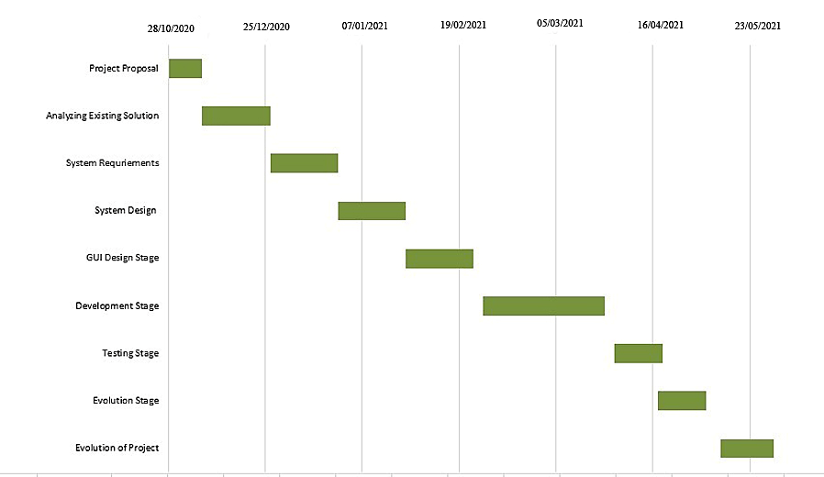The most influential constraint on our project is the amount of time available for development. To allow scheduling, estimation will have to be used to determine the probable length of time that each stage will require.

Figure 3.1 Gantt Chart.

chapter IV  
  
Methodology

Successful projects are well managed. To manage a project efficiently, we must have to choose the software development methodology that will work best for our project. All methodologies have different strengths and weaknesses and exist for different reasons. Here’s an overview of software process models and the methodology approach we have use for our project.

4.1 Process Model

Software Processes is a set of activities for specifying, designing, implementing and testing a complete software.

4.2 Different Software Process ModelS

1. Waterfall Model.
2. Incremental Model
3. Spiral Model
4. Iterative Development Model
5. Agile Model
6. Prototype Model

4.3 Why we choose agile model?

We have chosen agile model for our project. Because, it is more adaptable than some of the other models. When any requirement changes in the mid time of the development process it is easier to adapt with the change in agile model.

The chances of absolute project failure is less in agile model than other software development models [8]. For this, we choose agile model for our project.

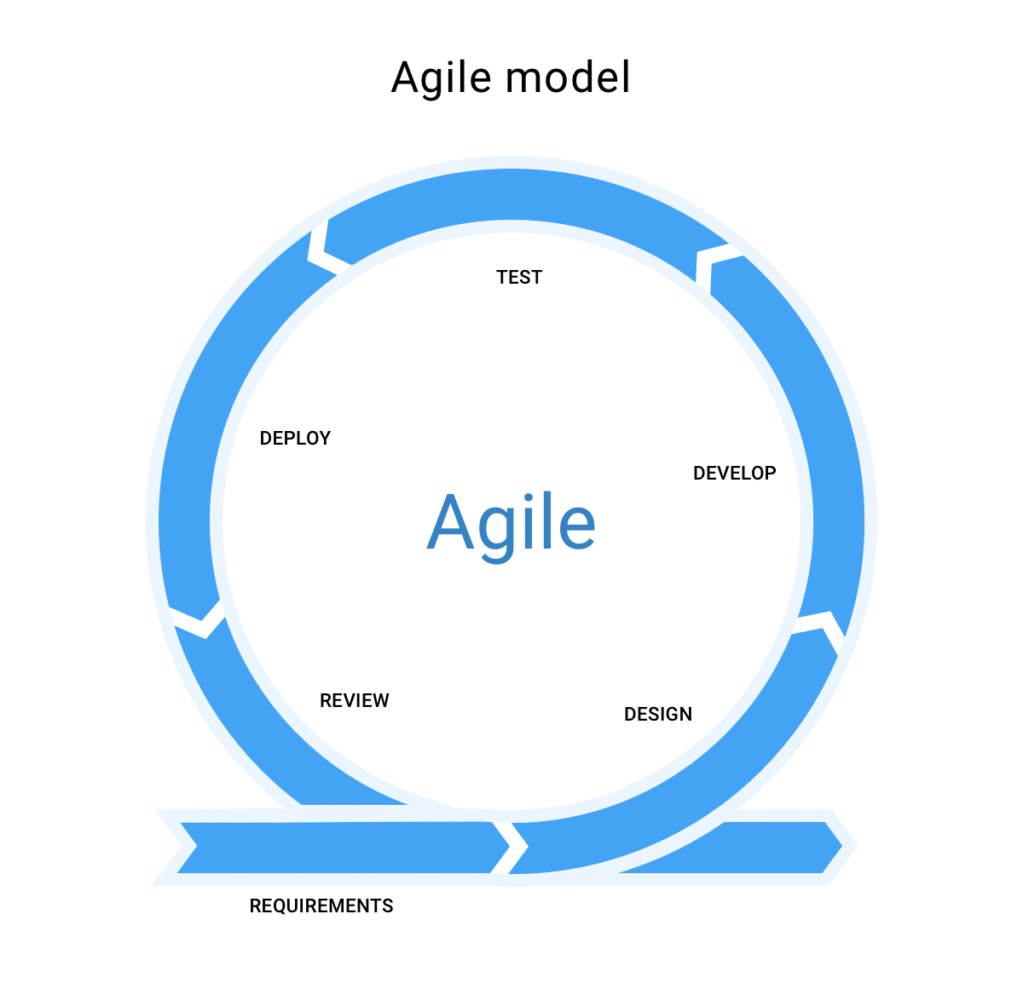

Figure4.2 Agile Model [9]

4.4 Agile model implementataions

As we used agile approach in our project. We completed the phases properly one after another to avoid confict in development. The phases are described below in detail:

****4.4.1 Requirements****

It is the primary period of the development where every one of the prerequisites accumulated and documented. For our project we have examined previous related systems and the users. After that we have finalized our system features.

4.4.2 Design

After getting a good grasp of the basic technical requirements. In that stage we have prepared the system design according to the architecture. For our project we have used XML for mobile application and the web panel using HTML, CSS and Bootstrap.

4.4.3 Implementation

After approving the product requirements and design, there is a transition to the next stage of the lifecycle: implementation or development of functional end. Here we start coding and performed all the development works and development components or units handed over for testing. For this project we did all implementations here. For implementing android application, we have used JAVA and for Web panel we have used PHP, MYSQL.

****4.4.4 Testing****

After finishing development phase testing phase starts. We test each unit or component and make sure the developed components are working as expected. All the testing activities are performed in this phase. In case of our project we have done white box testing and completed usability testing among some users. We have done various validity check from each panel many times. We have checked server connection request execution error with debugging mode before final deployment. We will discuss about system testing briefly in chapter 6 ‘System Implementation and Testing”.

4.4.5 Deployment

Once testing is completed we make sure there is no bug or defect or any kind of issue, then project is deployed to production. Once product is deployed to production the end users start using the product. For our project we tested the function of the application in few android OS version. We also fixed a few bugs related to deployment issue.

4.4.6 Review & Maintenance

We always keep eye on the product and provide all the necessary bug or issue fixes if occurs in production or reported by end users. Also, time to time we keep updated the product with new updates or patches if developed or available. For our project we will try to observe the app continuously and keep the app up-to-date.

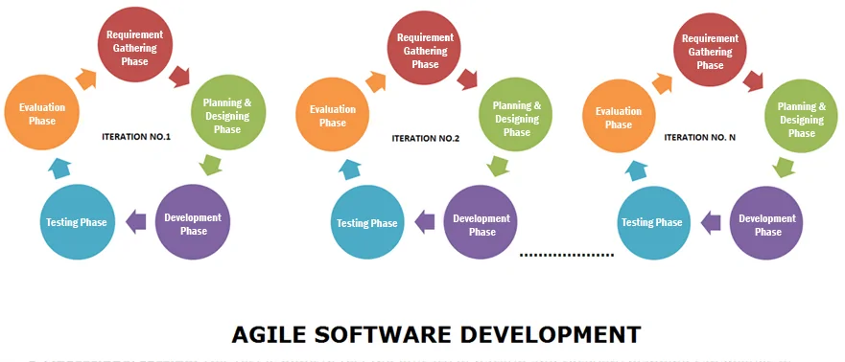

app continuously and keep the app updated

Figure4.2 Agile Model for Software Development [10]

4.5 Limitations of agile model

There are some limitations of using agile model in porject [11] -

1. Due to lack of processes sometimes team members get [easily sidetracked](https://www.lucidchart.com/blog/3-disadvantages-of-agile-methodology#agile).
2. [Long-term projects suffer](https://www.lucidchart.com/blog/3-disadvantages-of-agile-methodology#agile%20methodology) from incremental delivery.
3. The [level of collaboration](https://www.lucidchart.com/blog/3-disadvantages-of-agile-methodology#disadvantages%20of%20agile) can be difficult to maintain.
4. There is lack of emphasis on necessary designing and documentation

chapter V  
  
System ANalysis

A system is a special design that is physical and functional need. System analysis is conducted for the purpose of studying a system or its parts in order to identify its objectives [13].

5.1 System Analysis

System analysis is the technique of studying a system or its components in order to identify its objectives. It improves the system and ensures that all the components of the system work efficiently to accomplish their purpose.

5.2 Data flow of SDMS App

Data flow is which is the way of sending data to server and receive them to android application. The process is figured out below:

Data Receive

**JSON Format**

Data received by device

Connect

Request for data

**SERVER**

**PHP**



Request from device

Request receive by PHP file

**HTTP Post Method**

Figure 5.1: System Data Flow of SDMS Mobile App

5.3 Data view

In SDMS APP we have used very frequently list views. So, the very important things is to present list view items in an excellent way. Data is receiving by the device, list views generation process starts along this. In SDMS APP the data view representation always followed an efficient manner where the view problem in interface will not be taken place in future use.

5.4 Security

In SDMS APP we have used many security features. It creates a secure environment of passing JSON data while need a connection. Prepared Statement for passing database query connections so that internally system can prevent various attacks and outside access. To store sensitive information in database we have used “Bcrypt” encryption. It uses a 128-bit salt and encrypts a 192-bit value. It will help to secure our information more.

5.5 Version support

As an android application, SDMS APP must be supported on most of the android versions. SDMS APP will be supported by android version Jelly Bean 4.2 and higher versions.

5.6 System Design

**Objective:** To change of the system detail into and operational system plan.

**Input:**  project goals, users requirements and specifications.

**Process:** Making alternatives to make economic benefits and building a qualityful system for major uses.

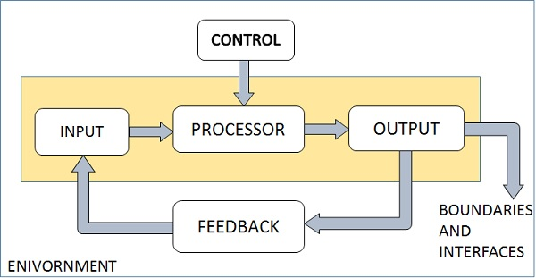**Output:** system design, schedule, software and hardware requirements.

Fig 5.1: Elements of system [13]

5.7 A general Model of software design process

DATA INPUTS

DATABASE DESIGN

DATA DESCRIPTION

REQUIREMENTS SPECIFICATION

PLATFORM INFORMATION

DATA ACTIVITES

A

INTERFACE DESIGN

COMPONENT DESIGN

ARCHITECTURAL DESIGN

DATA OUTPUTS

COMPONENT SPECIFICATION

INTERFACE SPECIFICATION

DATABASE SPECIFICATION

SYSTEM ARCHITECTURE

Figure 5.2: A general Model of software design process [14]

5.8   Flow chart Diagram

5.8.1 Flow Chart Diagram for Teacher Panel

**Teacher Sign-In**

**User-cell & Password**

**Settings**

**Messages**

**Forum**

**Couse Requests**

**Assignments**

**Notices**

**Courses**

Figure 5.3: Teacher Panel Activity diagram of the system.

5.8.2 Flow Chart Diagram for Student Panel

**Student Sign-In**

**Student ID & Password**

**Settings**

**Messages**

**Forum**

**Faculties**

**Assignments**

**Notices**

**Courses**

Figure 5.4: Student Panel Activity diagram of the system.

5.8.3 Flow Chart Diagram for Admin Panel

**Admin Sign-In**

**E-mail& Password**

**Course Registration**

**Re**

**Assigned Courses**

**Courses**

**Students**

**Teachers**

**Dashboard**

**Faculty Information**

**Message**

**Set Up**

**Forum**

**Notice**

Figure 5.5: Admin Activity diagram of the system.

5.9   Use Case Diagram

5.9.1 Use Case Diagram for Teacher Panel

Registration Verification & Sign-in

Explore Assigned Courses

Give section, course notices and view official notices.



Give course assignment and preview submitted assignments.

View course request and different action of the courses.

**Teacher**

Create post, view all post and comment in academic forum.

Search and send real-time messages to students.

Navigate and edit profile

Sign-Out

Figure 5.6: Use Case diagram for Teacher Panel

5.9.2 Use Case Diagram for Student Panel

Registration Verification & Sign-in

Explore All Courses and register new course. View all registered courses.

Give section notice. View course notices and official notices.



View complete detailed list of department faculties.

Explore course assignments. Submit and preview submitted assignments.

**Student**

Create post, view all post and comment in academic forum.

Search and send real-time messages to teachers.

Navigate and edit profile

Sign-Out

Figure 5.7: Use Case diagram for Student Panel

5.9.3 Use Case Diagram for Admin

Admin Login

View Dashboard

View and manage students list

View and manage teachers list

Manage courses and assign course to teacher



Manage assigned courses

**Admin**

Figure 5.8: Use Case diagram for Admin Panel

5.10 Entity Relationship Diagram

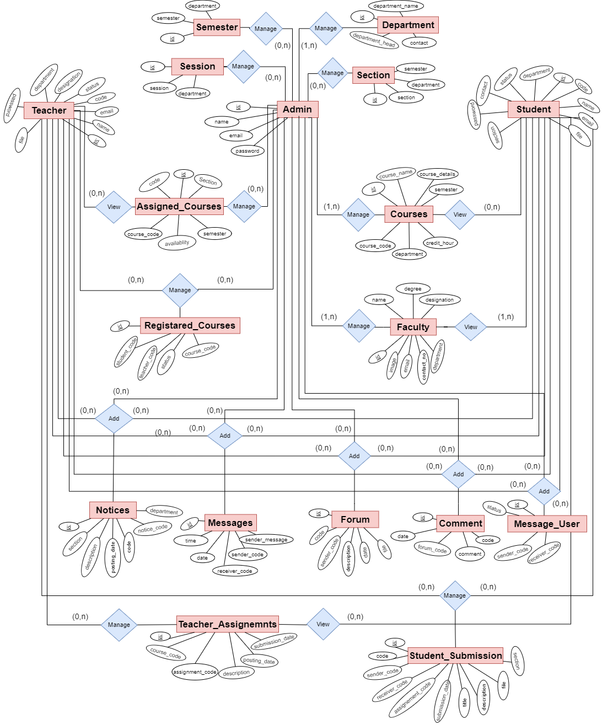

Figure 5.9: Entity Relationship Diagram

5.10.1 Logical Schema

* admin ( id, name , email, password)
* teacher (id, file, name, password, code, department, email, contact, designation status, token)
* student (id, file, name, password, code, department, email, contact, section, session, status, token)
* assigned_courses (id, code, course_code, course_semester, section, availability)
* courses (id, course_name, course_details, course_code, semester, credit_hours, department)
* registerd_courses (id, student_code, teacher_code, course_code, status, request)
* notices (id, notice_code, code, user_name, description, section, type, posting_date, departement )
* forum (id, forum_code, code, description, file, date, status)
* comment (id, forum_code, code, comment, date, status)
* message_user (id, sender_code, receiver_code, status)
* messages (id, sender_message, sender_code, receiver_code, date, time)
* teacher_assignments (id, assignenment_code, course_code, code, file, status, posting_date, submission_date)
* student_submission (id, assignment_code, teacher_code, course_code, titile, description, file, status, submission_date)
* faculty (id, name, image, degree1, degree2, degree3, desgination, department, contact_no, email)
* department (id, department_name, department_head, department_contact)
* semester (id, semester, department_name)
* section ( id, section_name, semester, departmnet_name)
* session (id, session, department_name)

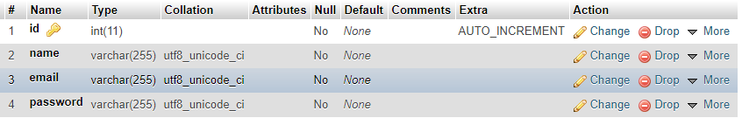

Fig 5.10 : Table ( admin )

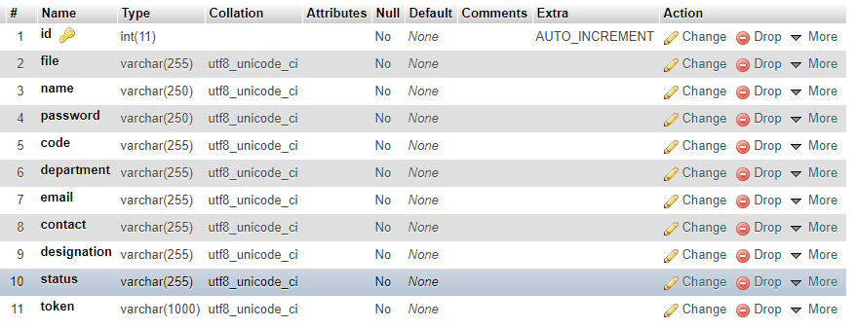

Fig 5.11 : Table ( teacher )

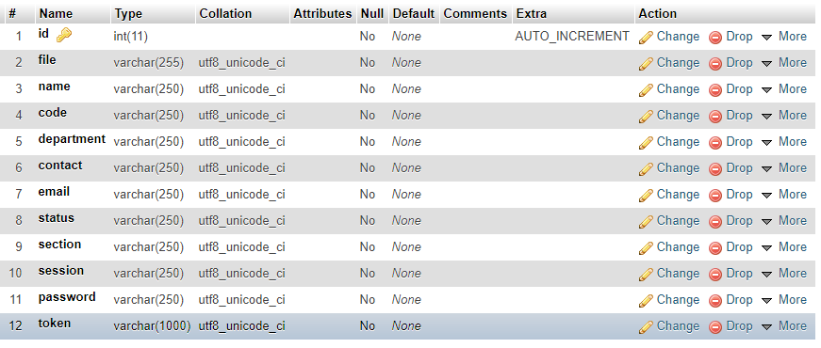

Fig 5.12 : Table ( student )

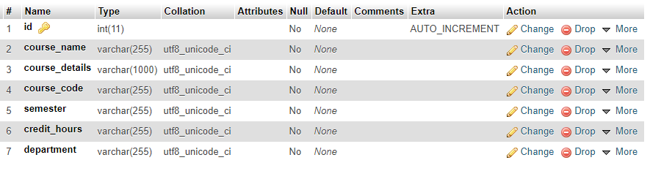

Fig 5.13 : Table ( courses )

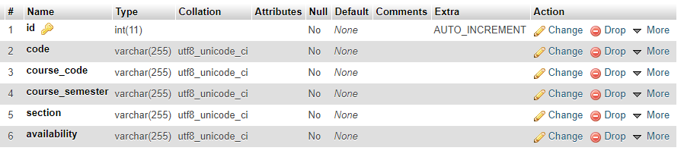

Fig 5.14: Table ( assigned_courses )

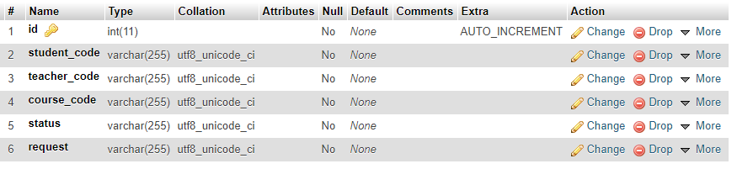

Fig 5.15 : Table ( registered_courses )

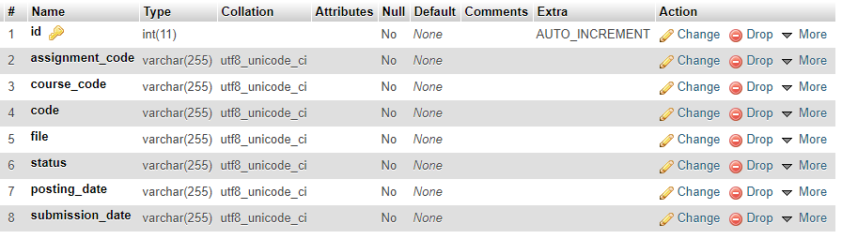

Fig 5.16 : Table ( teacaher_assignments )

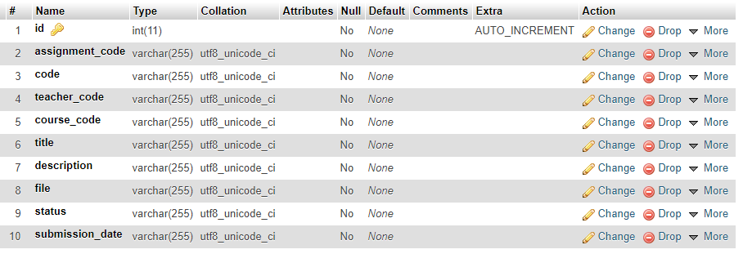

Fig 5.17 : Table ( student_submisions)

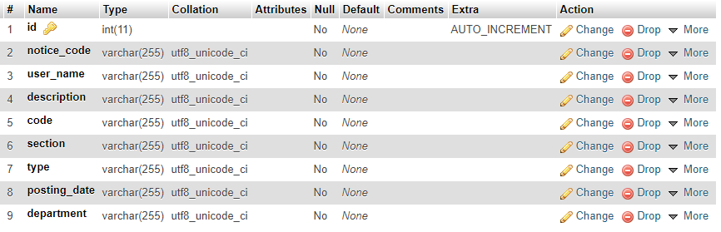

Fig 5.18 : Table ( notices )

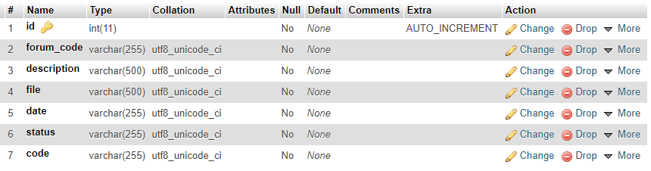

Fig 5.19 : Table ( forum )

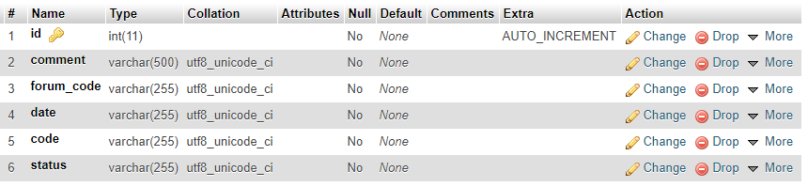

Fig 5.20: Table ( comment )

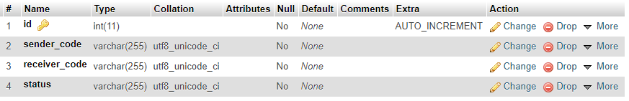

Fig 5.21 : Table ( message_user )

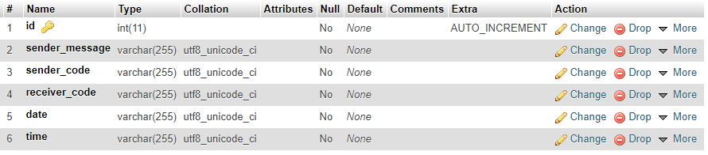

Fig 5.22 : Table ( messages )

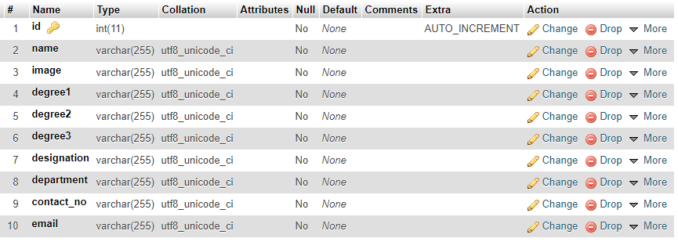

Fig 5.23 : Table ( faculty )

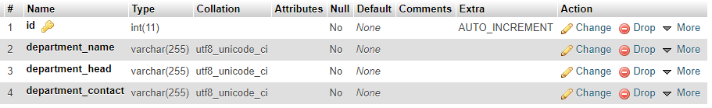

Fig 5.24 : Table ( department )

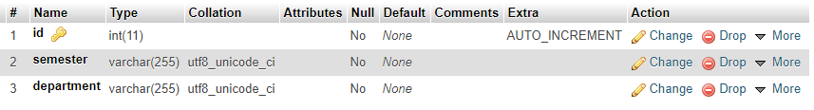

Fig 5.25 : Table ( semester )

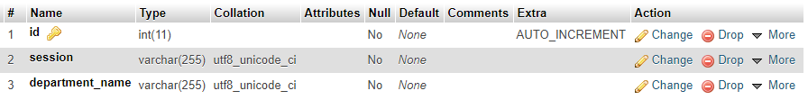

Fig 5.26 : Table ( session )

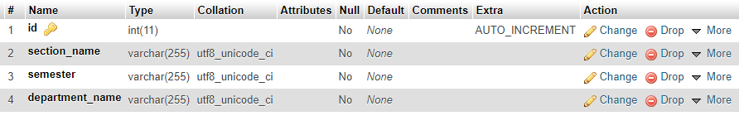

Fig 5.27 : Table ( section )

5.11 Data flow diagram

5.11.1 Level 0 DFD

Control

Administration System

Admin

Add/Edit Info/ Delete

View

Teacher

Content

Response

View

Student

Response

Content

Figure 5.28: Level 0 Data Flow Diagram for the Application

5.11.2 Level 1 DFD for Admin

Assigned Courses

**0**

**A Smart Course, Notice and Department Forum Management System**

Section notice, Official notice Add & Delete

**8.0**

Teacher

**2.0**

Teacher Info

Notice Info

Assigned Course List, Remove

**4.0**

Assigned Course

Info

Manage dept. forum, Add & delete post.

**7.0**

Forum Info

Student

Student Info

Students List Verify, Update, Delete

Courses

Course List, Add, Assign, Update & Delete

Teachers List Verify, Update, Delete

Course Info

**1.0**

**3.0**

Faculty List, Add, Update & Delete

Faculty Info

Manage messages to user & delete

**9.0**

Message Info

**6.0**

Course Registration List & Manage

Course Registration Info

Course Registration

Faculty

Forum

Notices

Message

**5.0**

Figure 5.29: Level 1 Data Flow Diagram for Admin of the Application.

5.11.3 Level 1 DFD for Teacher

**0**

**A Smart Course, Notice and Department Forum Management System**

Explore all assigned courses & manage courses.

**1.0**

Search & Send message to students.

**6.0**

Post section and course notices & view official notices

**2.0**

Post and comment in forum. Manage posts

**5.0**

Assigned Course Info

Notice Info

Forum Info

Message Info

**7.0**

Teacher

Teacher Info

Update profile information

Manage course assignments for all registered students.

Manage all registered students for course.

Assignment Info

Course Request Info

**3.0**

**4.0**

Assigned Courses

Notices

Teacher

Assignments

Course Request

Forum

Messages

Figure 5.30: Level 1 Data Flow Diagram for Teacher Application.

5.11.4 Level 1 DFD for Student

**0**

**A Smart Course, Notice and Department Forum Management System**

Explore all courses & manage courses.

**1.0**

Search & Send message to teachers.

**6.0**

Post section notice & view course, official notices

**2.0**

Post and comment in forum. Manage posts.

**5.0**

Course Info

Notice Info

Forum Info

Message Info

**7.0**

Update profile information.

Student Info

Submit & Manage course assignments for all registered courses.

View and Contact department faculties.

Assignment Info

Faculty Info

**3.0**

**4.0**

Courses

Notices

Student Submission

Faculty

Forum

Messages

Student

Figure 5.31: Level 1 Data Flow Diagram for Student Application.

chapter VI  
  
System Implementation & Testing

Android applications are spreading widely and are rapidly used as an operating system for Smartphone, tablet and other devices. Android development is now focusing on giving support to people in every other steps of life. By using our user friendly android application the students and the teachers will get an easier way to be connected with own department.

6.1 SYStem implementetaion in details

In android app there are 2 panels.

* Teacher Panel
* Student Panel

In web there are a panel for Admin.

* Admin Panel

6.1.1 Teacher Panel

To use the teacher panel user must need to complete signup process of teacher. After department admin verification user can sign-in to the home activity and access the functionalities. In our application branch Teacher Panel has versatile features

* **Courses** – Here teacher will see the courses are assigned to them the admin and could make them available or unavailable for students.
* **Notices**
* Section Notice – Teacher can give notice to any section and see the list of previous given section notices.
* Course Notice – Teacher can give notice to their registered students of the assigned courses and see the list of previous given course notices.
* Official Notice – Only the notices which are given as official notice by the admin will be listed here.
* **Assignments**
* All Assignment – Teacher can give new assignment to the assigned courses and see the list of the previous given course assignments. Can delete previous assignments.
* Submitted Assignments – Teacher can see the list of submitted assignments and can preview the submitted files.
* **Course Request** – Course request from the students to join the course will appear here.
* **Forum**
* All Posts – Teacher can see all forum posts and can give new post to the forum. Can add comments to any post.
* My Posts – The previous given post will be shown here. Can delete or modify any post.
* **Messages** – Teacher can search by student Id, name or section. Send new messages to students and can see message list.
* **Profile Setting** – Can update all information, image etc.
  + 1. Student Panel

To use the teacher panel user must need to complete signup process of teacher. After department admin verification user can sign-in to the home activity and access the functionalities. In our application branch Student Panel has versatile features

* **Courses**
* All Courses – Student will see all courses of the department.
* My Courses – All registered courses will appear here.
* **Notices**
* Section Notice – Student can give notice to his section and see the list of previous section notices
* Course Notice – Student can see the notices of the course that they have registered.
* Official Notice – Student can see official notices which has given by the department.
* **Assignments**
* Course Assignments – Student will see the list of assignments which are given for their registered courses. Can separate the assignment by course.
* My Submissions – Can preview the submitted assignments. Delete submission.
* **Faculties** – Complete detailed list of department faculties with tap to contact feature.
* **Forum**
* All Posts – Student can see all forum posts and can give new post to the forum. Can add comments to any post.
* My Posts – The previous given post will be shown here. Can delete or modify any post.
* **Messages** – Student can search by teacher name. Send new messages to teacher and can see message list.
* **Profile Setting** - Can update all information, image etc.
  + 1. Admin Web Panel

This panel provides the unique facility to the Admin to control all the aspects of the whole system. This web panel offers a user-friendly and interactive experience to the Web admin. Adding new objects and updating them. Viewing and managing all old data. Actions of the web panel is very easier to understand and also easier to maintain all updated information. In our application Admin Web Panel is much versatile. It consists of 14 sub panel activity.

* **Dashboard** – Home window after log in. Admin can access important features from here.
* **Teachers** – All teachers list. Admin will verify newly registered teachers. Admin have update and delete operation.
* **Students** - All students list. Admin will verify newly registered students. Admin have update and delete operation.
* **Courses** - All course list will be shown here. Admin can create, update, assign or delete courses.
* Assign Course – Admin can assign course to teacher.
* **Course Registration** – All students information’s of course registration will be appear here. Admin have delete operation.
* **Assigned Courses** – List of all assigned courses will be shown here. Admin have delete operation.
* **Faculty Information** – Admin can manage information of faculty list. Which will be shown in student panel as ‘Faculties’ section.
* **Forum** – Admin can manage all post of department forum also can create new post to the forum.
* **Notice** – All notices given by the admin will appear here as list.
* Section Notice – Admin can add notice for any section of the department.
* Official Notice – Admin can give official notice of the department.
* **Message** – Admin can send personal message to any Student and Teacher.
* **Section** – Admin can manage sections. Admin have create, update or delete operation for section.
* **Session** – Admin can manage sessions. Admin have create, update or delete operation for session.
* **Semester** – Admin can manage semester. Admin have create, update or delete operation semester.

6.2 UI Design Implementation

Here we will describe the UI Implementation into three main parts. These are:

1. Student Panel
2. Teacher Panel
3. Admin Panel

6.2.1 Student Panel

Student panel is one of the major part of the SDMS application. Because we implement this system by giving the supreme priority to the students and teachers.

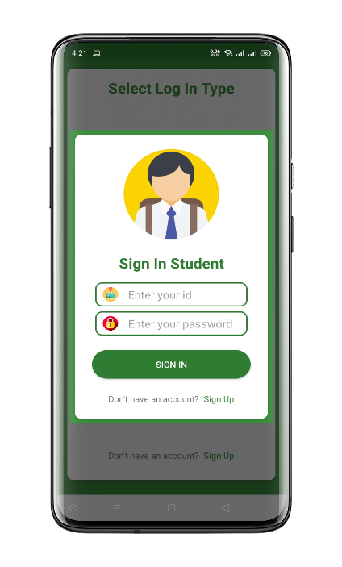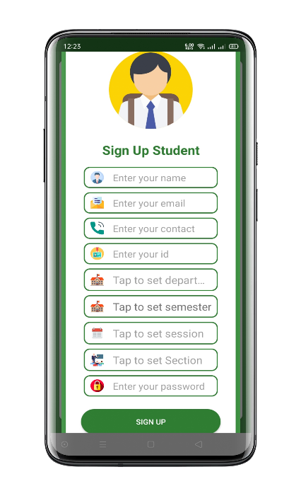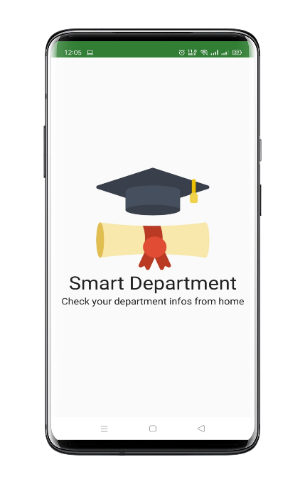Student can register himself by tapping on Sign-Up button. For Signing Up, student have to provide correct Full Name, Email, Contact number, Student ID, Department, Semester, Session, Section & Password. For Sign In, student have to provide correct Student ID & Password.

Fig 6.1:Student Sign Up Activity and Sign In Activity

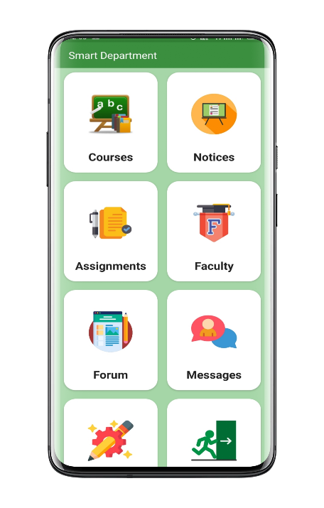After successful sign-in home activity will appear. Here students will see all short cut menu of the application.

Fig 6.3:Home Activity

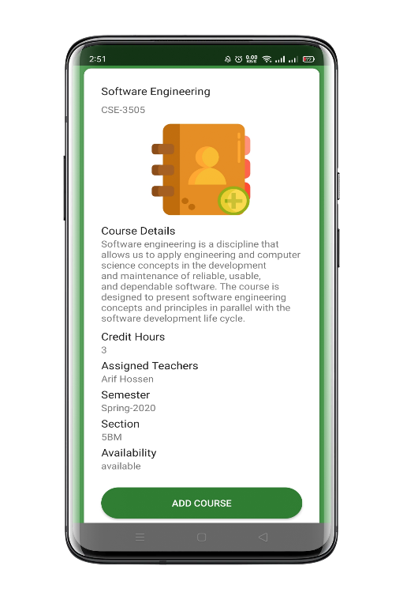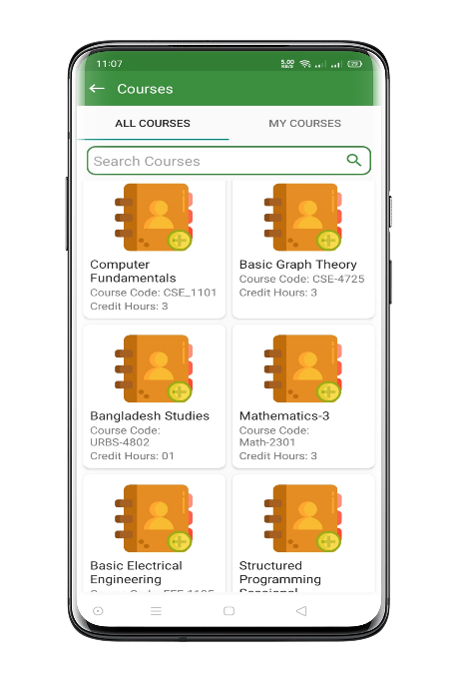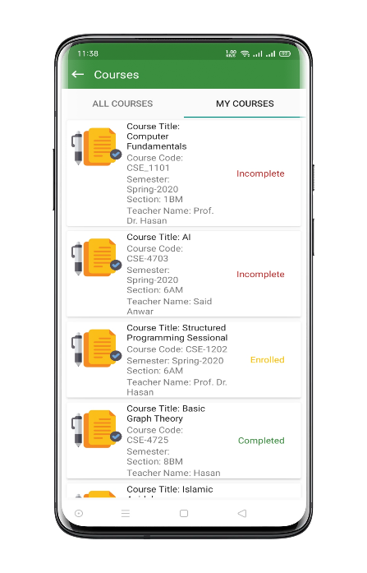**Courses:** Here student will see all courses which are offered and in “My Courses” activity the courses registered by them will appear.

Fig 6.4: Student Courses Activity

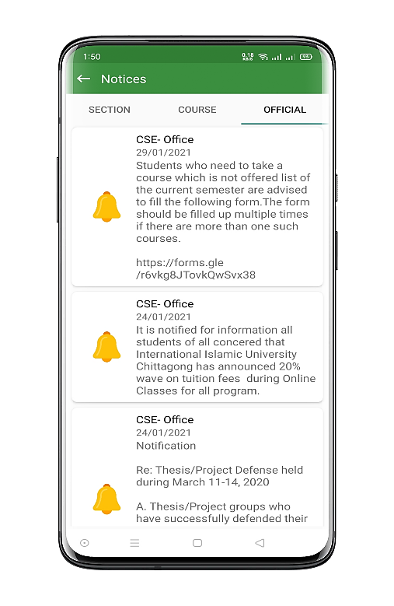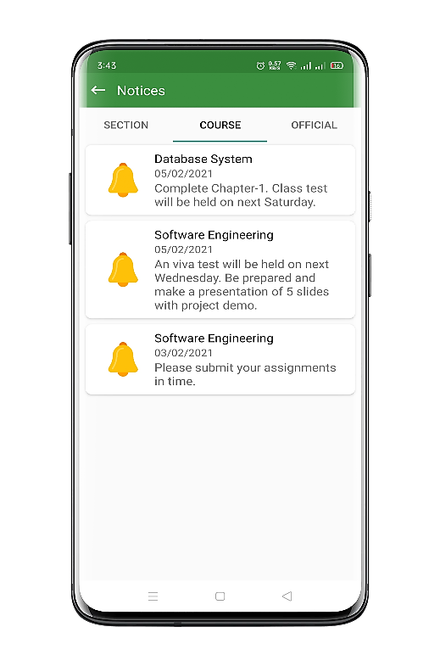**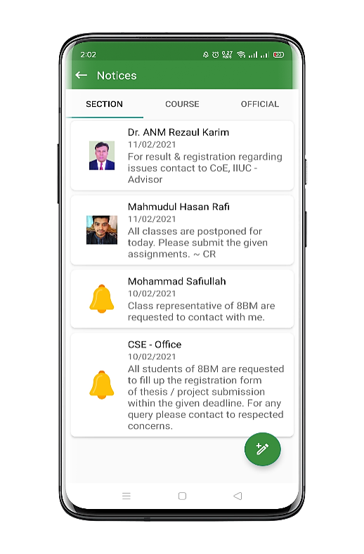Notices:** Students will get here the official notices announced by department, course notices announced by course teacher and section notices given by class represntative, teacher and department office.

Fig 6.5: Student notice activity

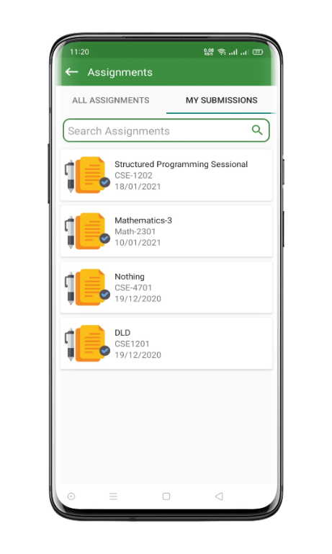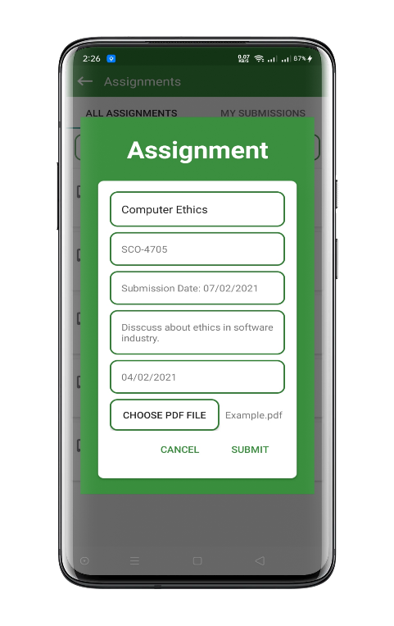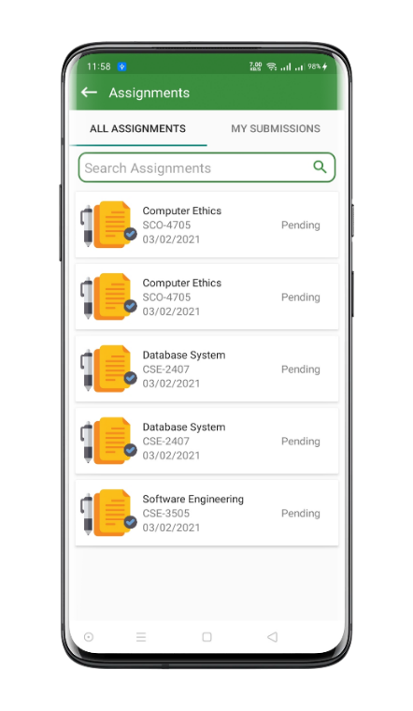**Assignements:** Students will see the assignments given by the course teachers and also can preview their submitted assignments.

Fig 6.6 : Student assignments activity

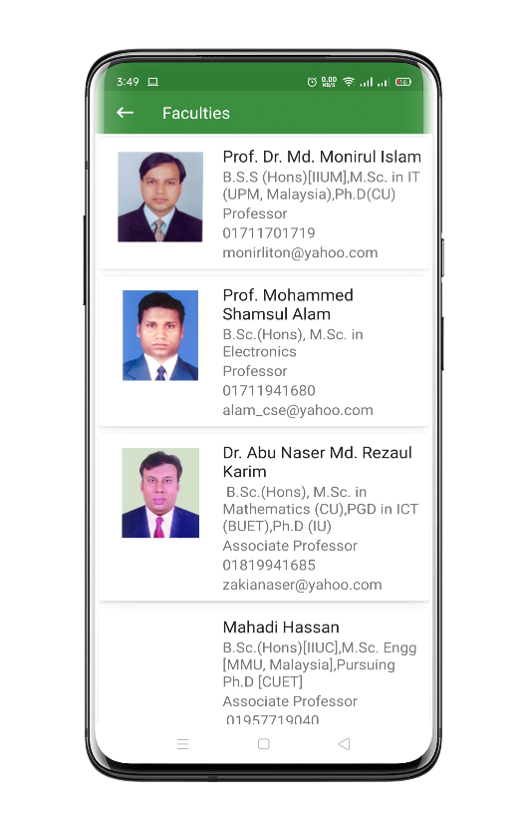**Faculties:** Students can explore all the faculty information in detailes from this activity and can contact easily with tap to contact action.

Fig 6.7: Faculty Activity for Students

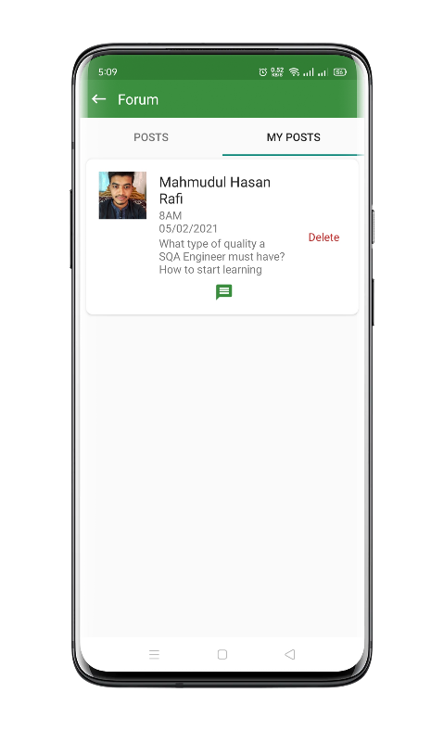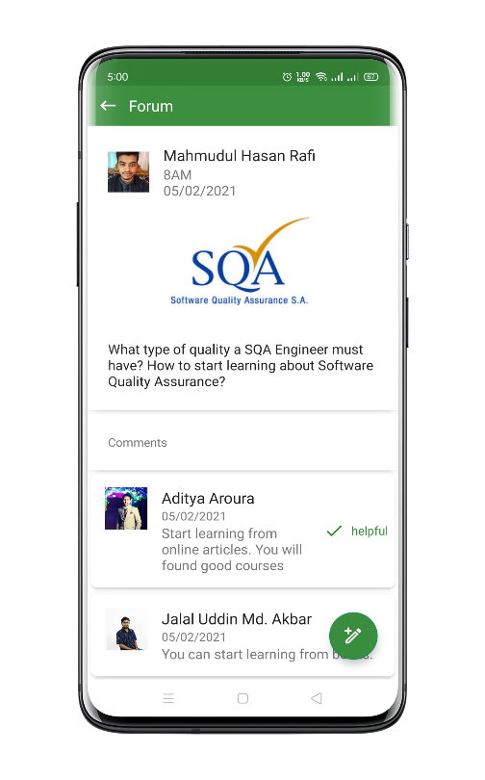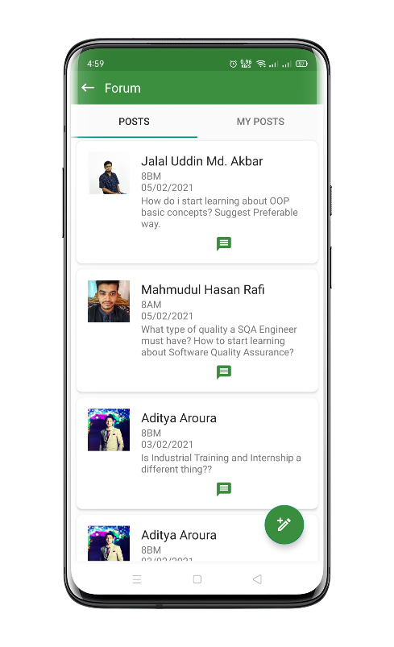**Forum:** Students can ask questions in forum and comment in others queries. In “My Post” activity student can manage their own posts.

Fig 6.8: Forum activity

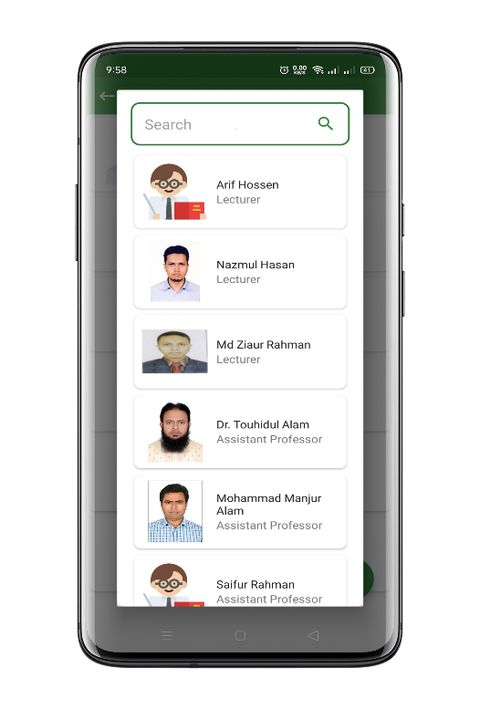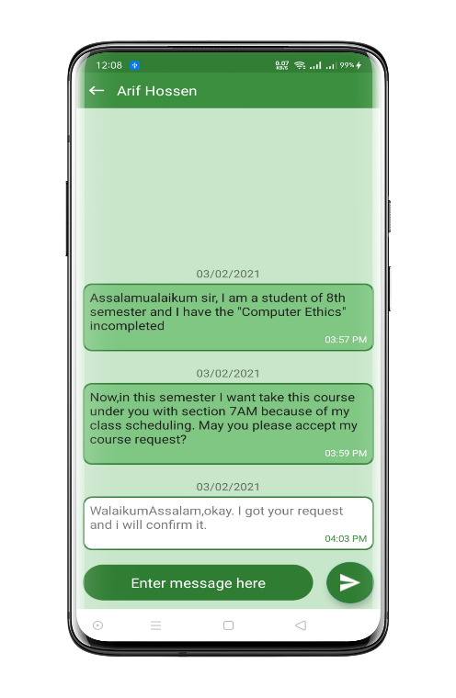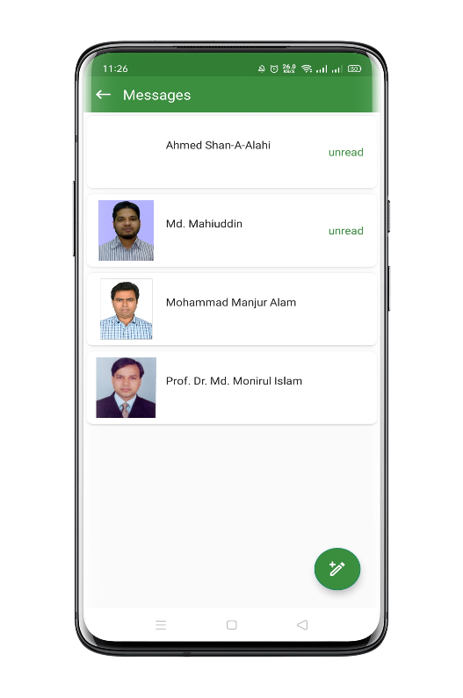**Messages:** Student can search for teachers by name and send real-time messages form this activity.

Fig 6.9: Student Message activity

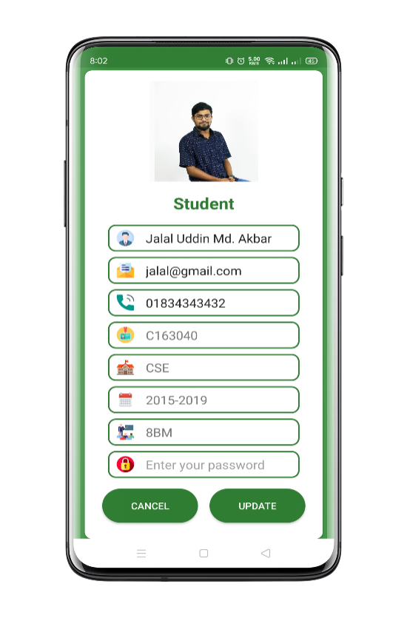**Profile:** On profile activity students can update their information and images.

Fig 6.10: Student profile update activity

6.2.2 Teacher Panel

Teacher Panel is another major part of SDMS APP. In this panel we did lot of improvement. App interfaces are user friendlies it is one of the main priorities of the application.

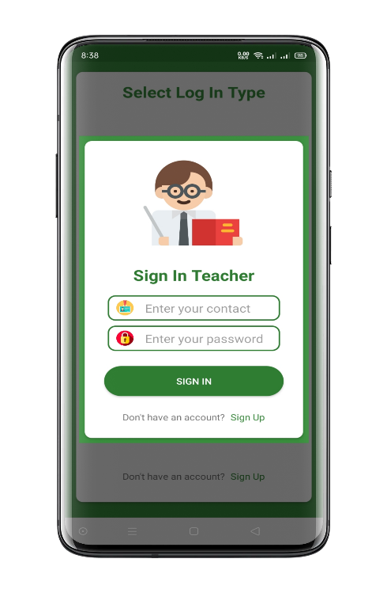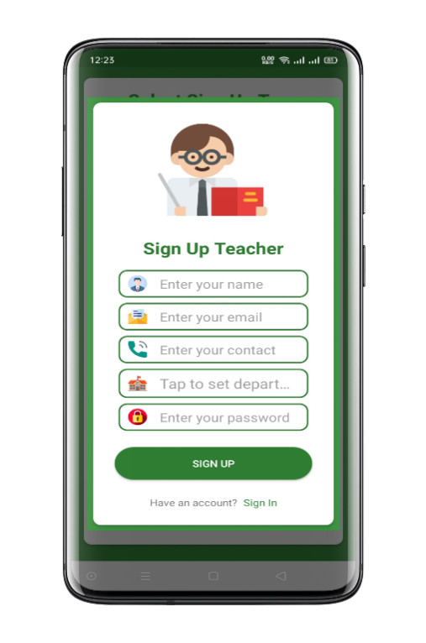Sign-up activity for teachers basically requires general information of the teachers to sign-up. General information like Name, Contact no, Email, Department and Password.

Fig 6.11: Teacher Sign-up activity

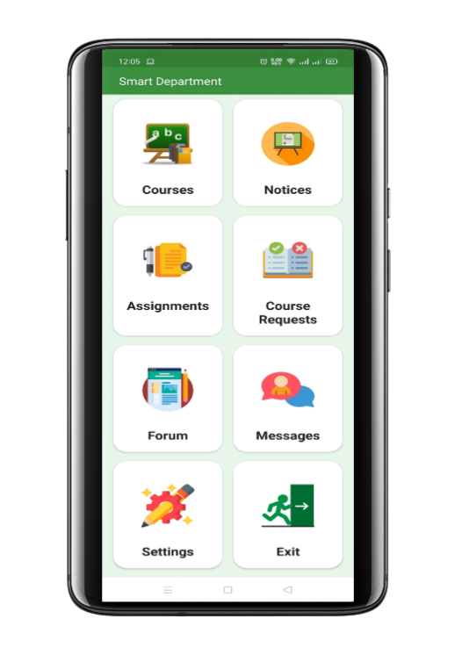After successful sign-in home activity will appear. Here teacher will see all short cut menu of application.

Fig 6.12: Home screen activity

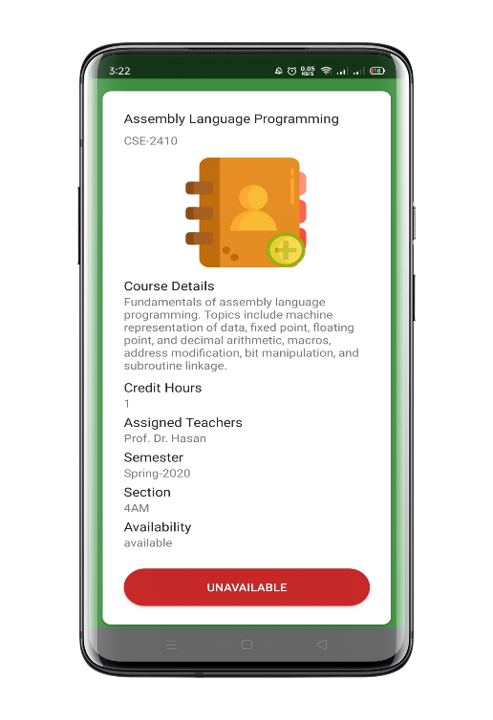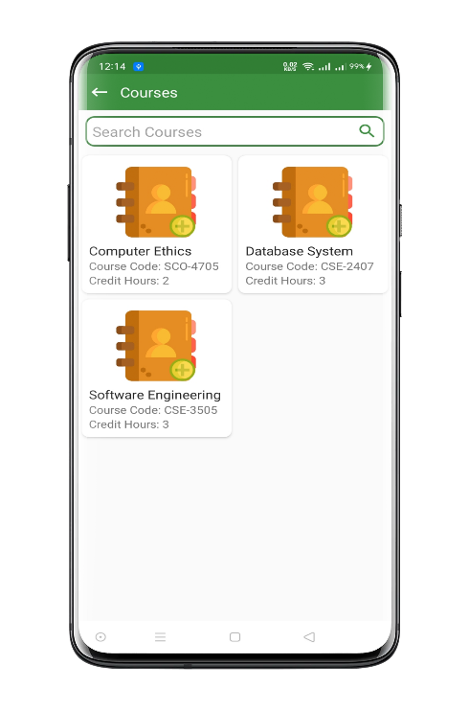**Courses:** In this activity courses which are assigned for the teacher from department will appear.

Fig 6.13: Teacher Courses activity

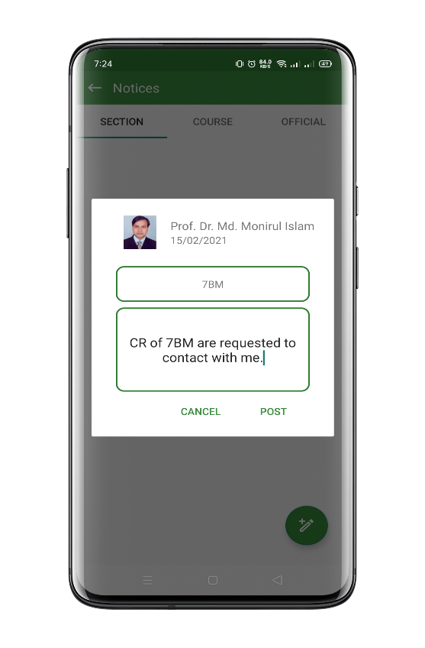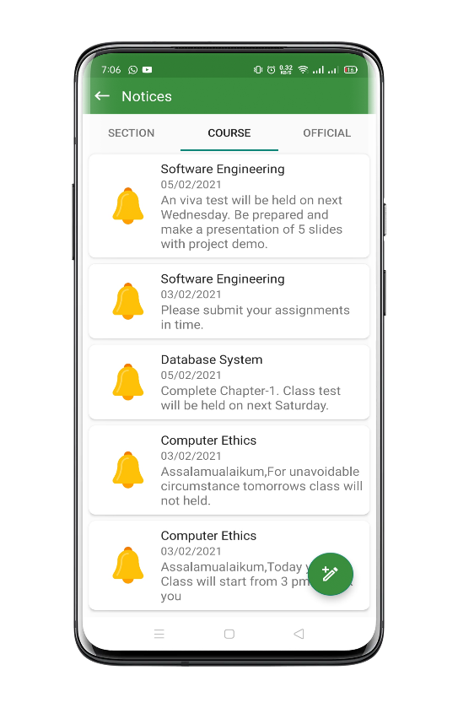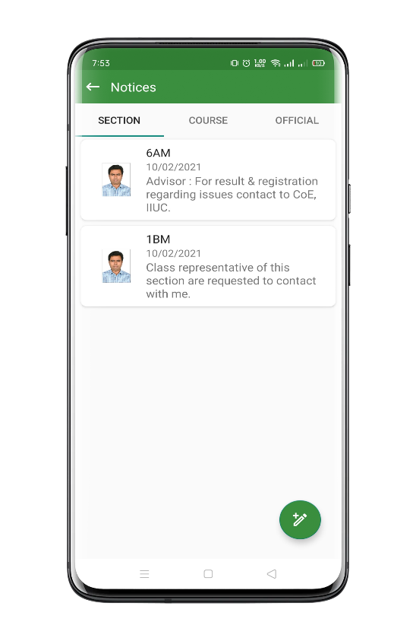**Notice:** In the notice activity, teachers can give notice to the assigned courses. Teacher can give notice to specific section. In the official notice tab official notices form department will appear.

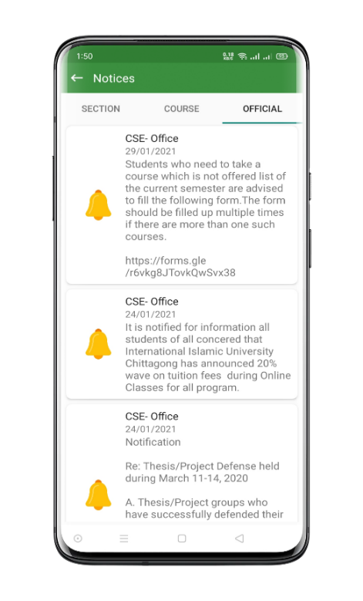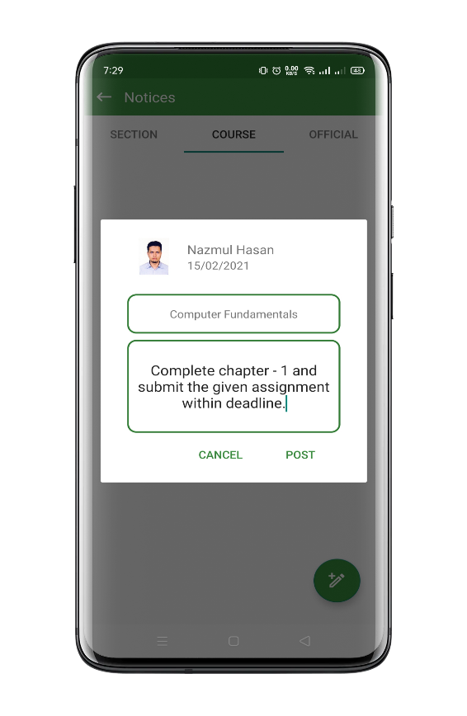

Fig 6.14: Teacher section, course and official notice activity

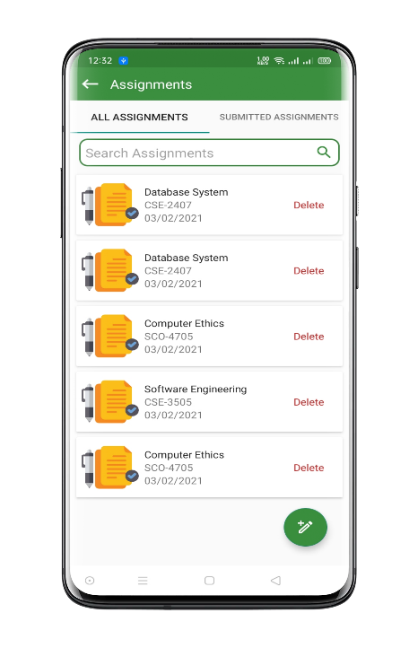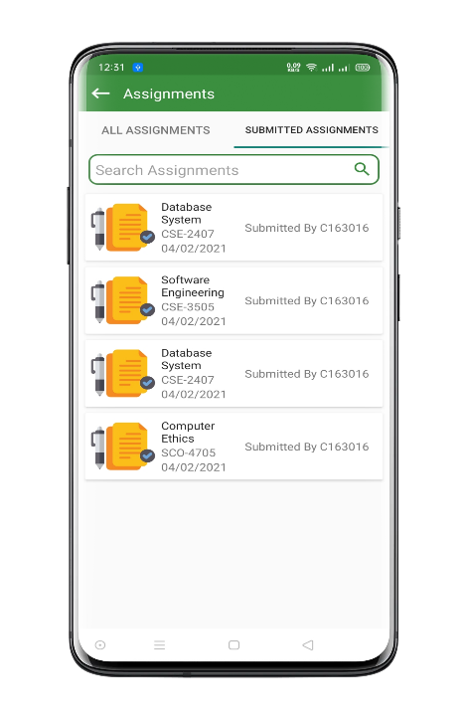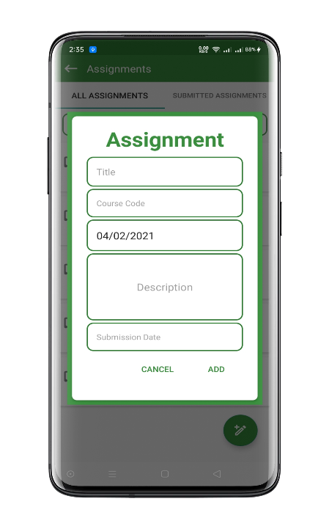**Assignment:** In this activity, all assignments added by teacher will appear and in the “Submitted Assignments” student submission will appear and teacher can preview the submission.

Fig 6.15: Teacher Assignment activity

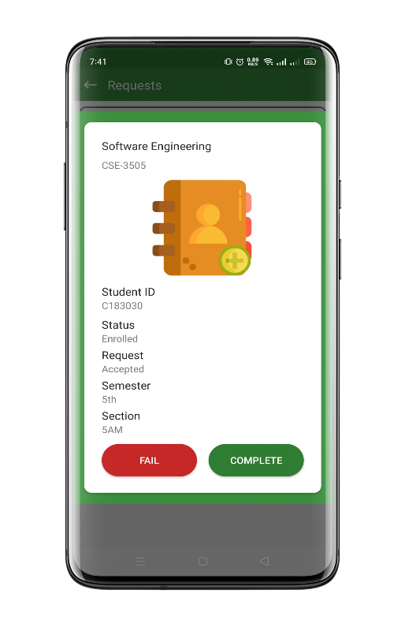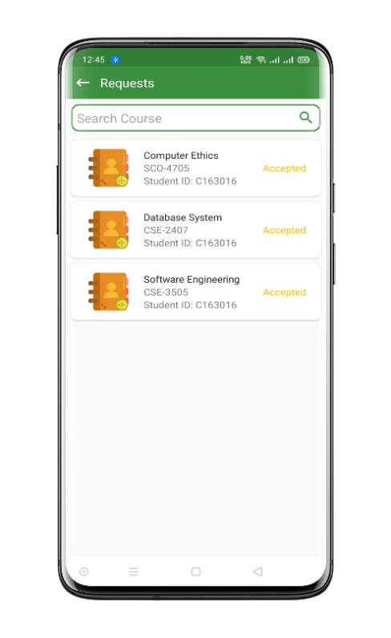**Course Request:** In this activity the course joining request by the students will appear and teacher can manage various course actions of students.

Fig 6.16: Teacher Course requests activity

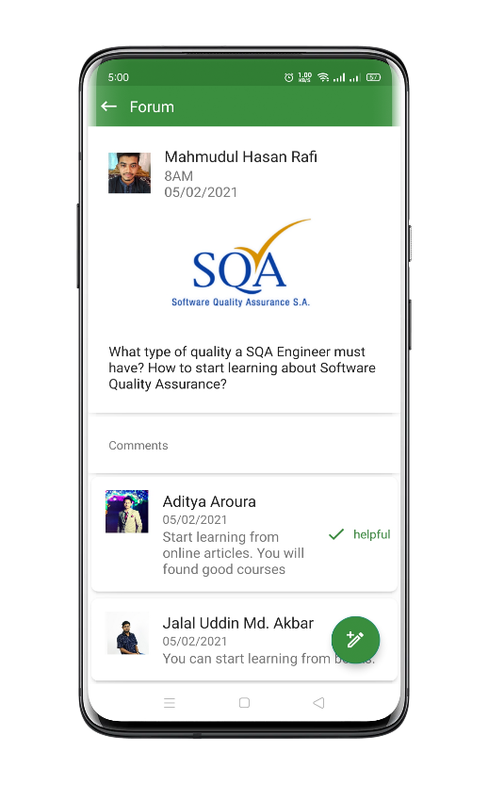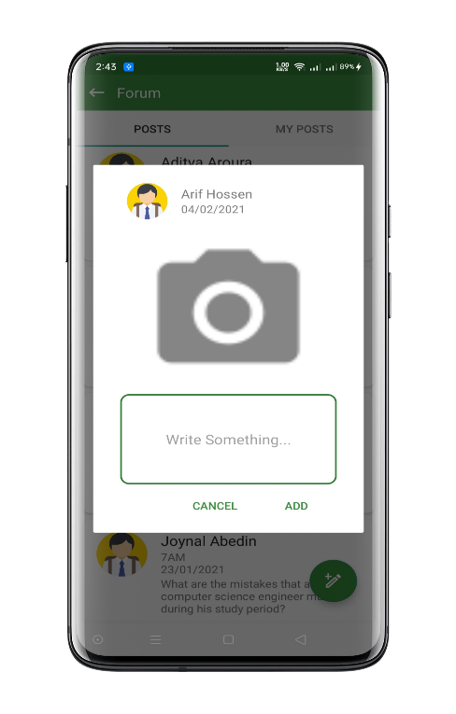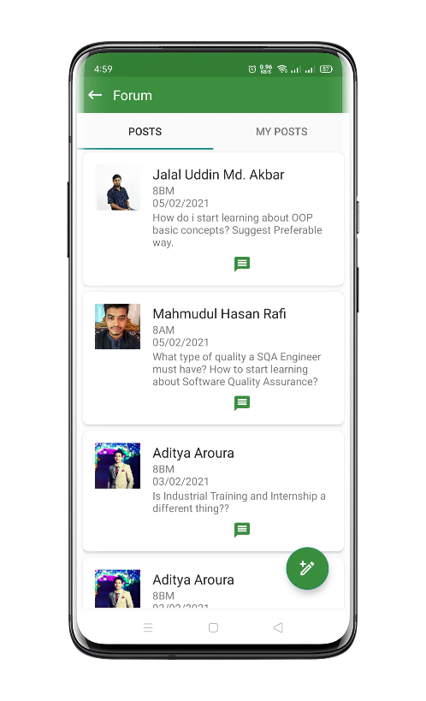**Forum:** In fourm activity teacher can post questions in forum and comment in others queries. In “My Post” activity teacher can manage own posts.

Fig 6.17: Forum activity

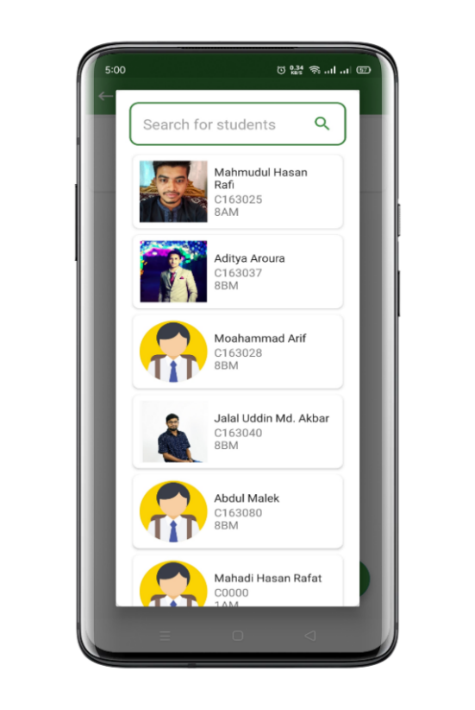**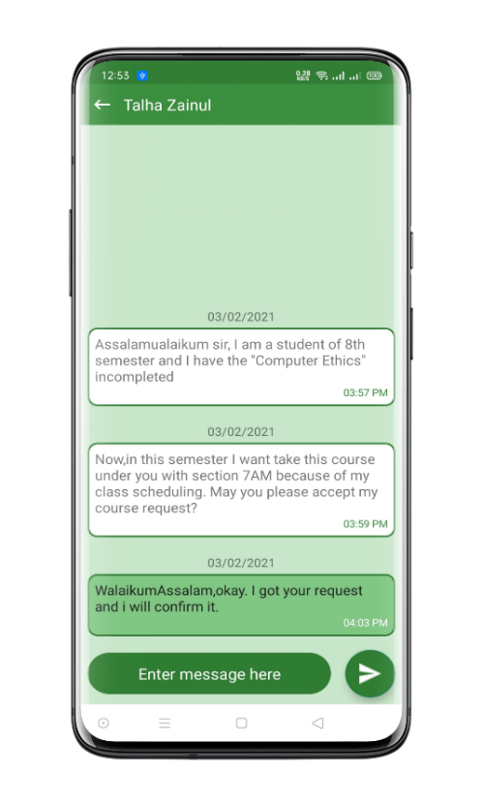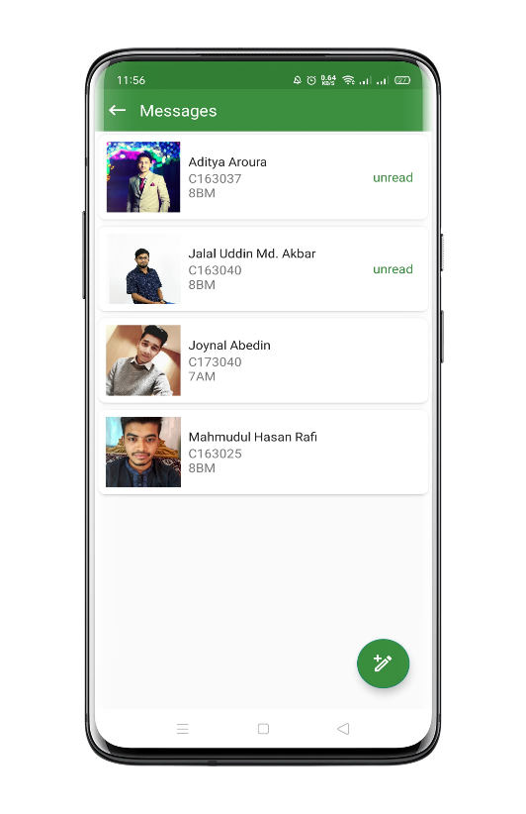Messages:** Teacher can search for students by name, id or section and can send real-time messages from this activity.

\\\

Fig 6.18: Teacher Message activity

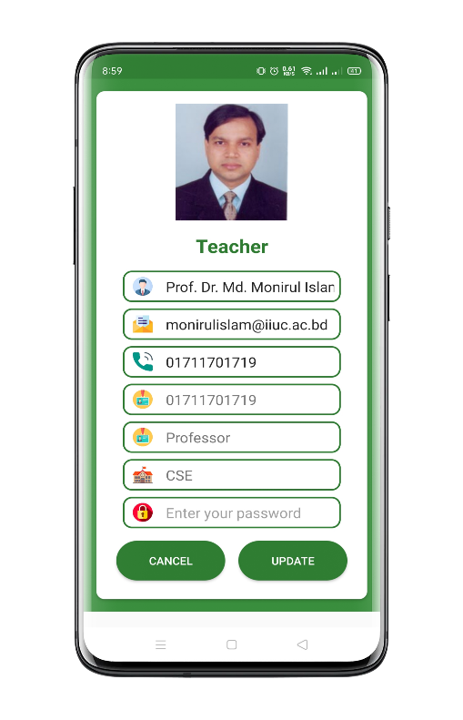**Profile:** In this activity teacher can update profile information and image.

Fig 6.19: Teacher profile update activity

6.2.3 Admin Panel

Admin Panel is managerial panel of our application. The management operation of different features are completed by admin.

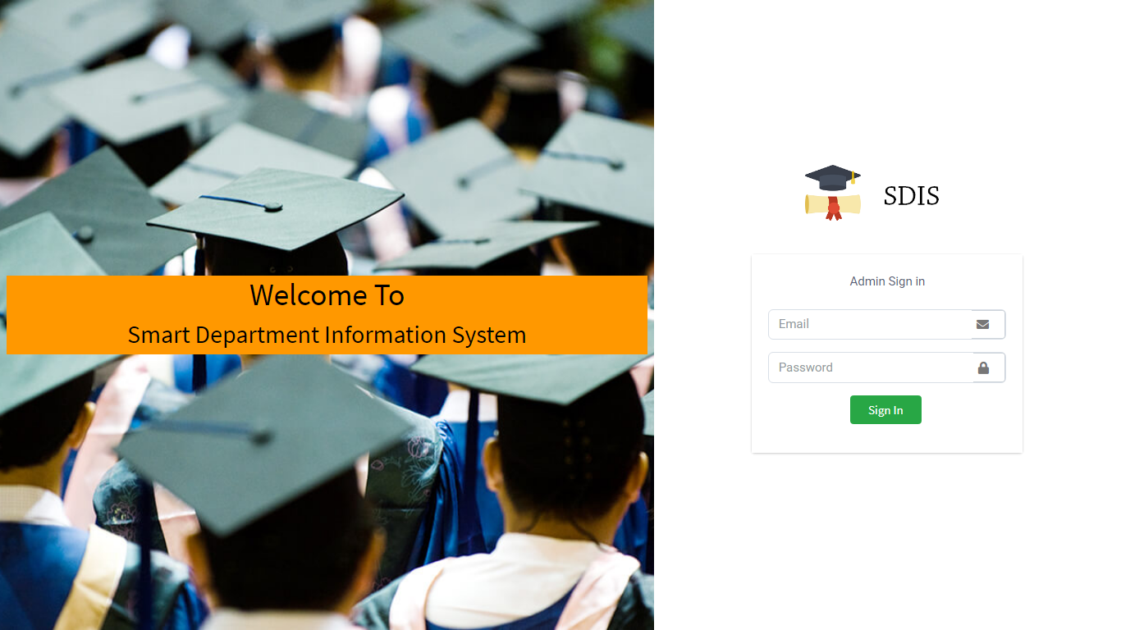

Fig 6.20: Admin panel sign-in activity

From here admin have sign-in to our application using their email & password.

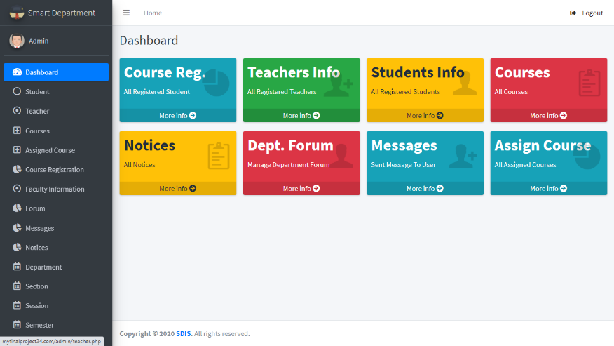

Fig 6.21: Dashboard for Admin

From dashboard admin can access all features of admin panel.

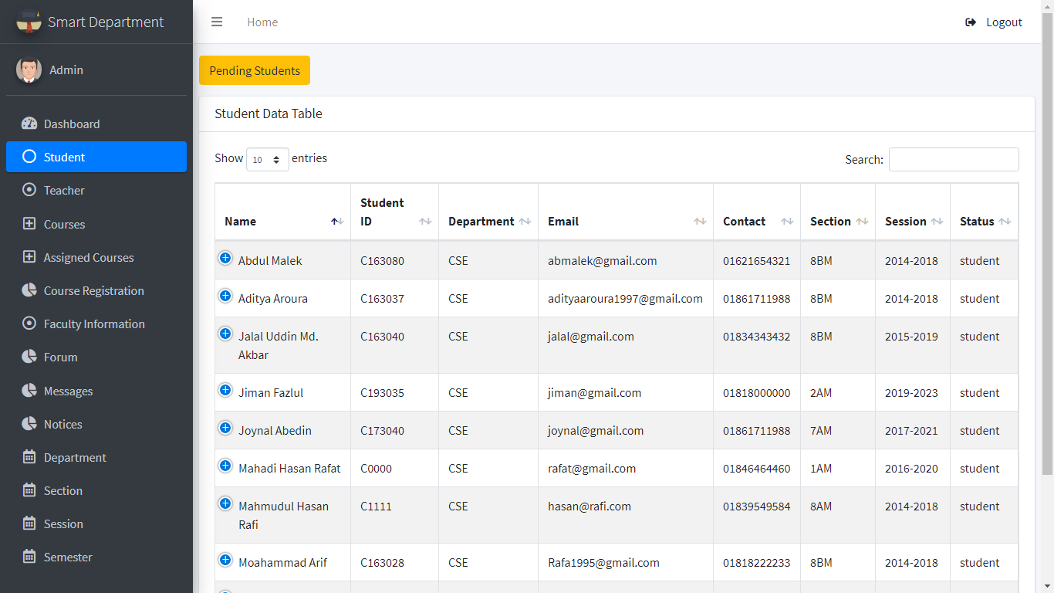

Fig 6.22: Student Management Activity for Admin

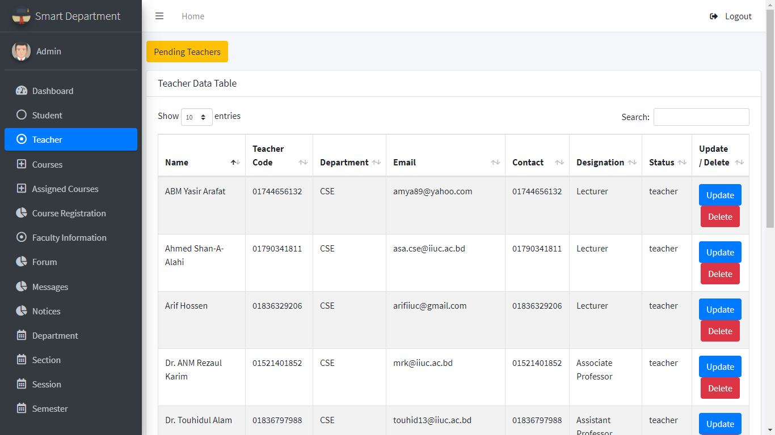Here admin can see the student’s information and can verify pending students. Admin can update and delete students Information.

Fig 6.22: Teacher Management Activity for Admin

Here admin can see the information’s of teachers. Admin can verify teachers and can update or delete teacher’s information.

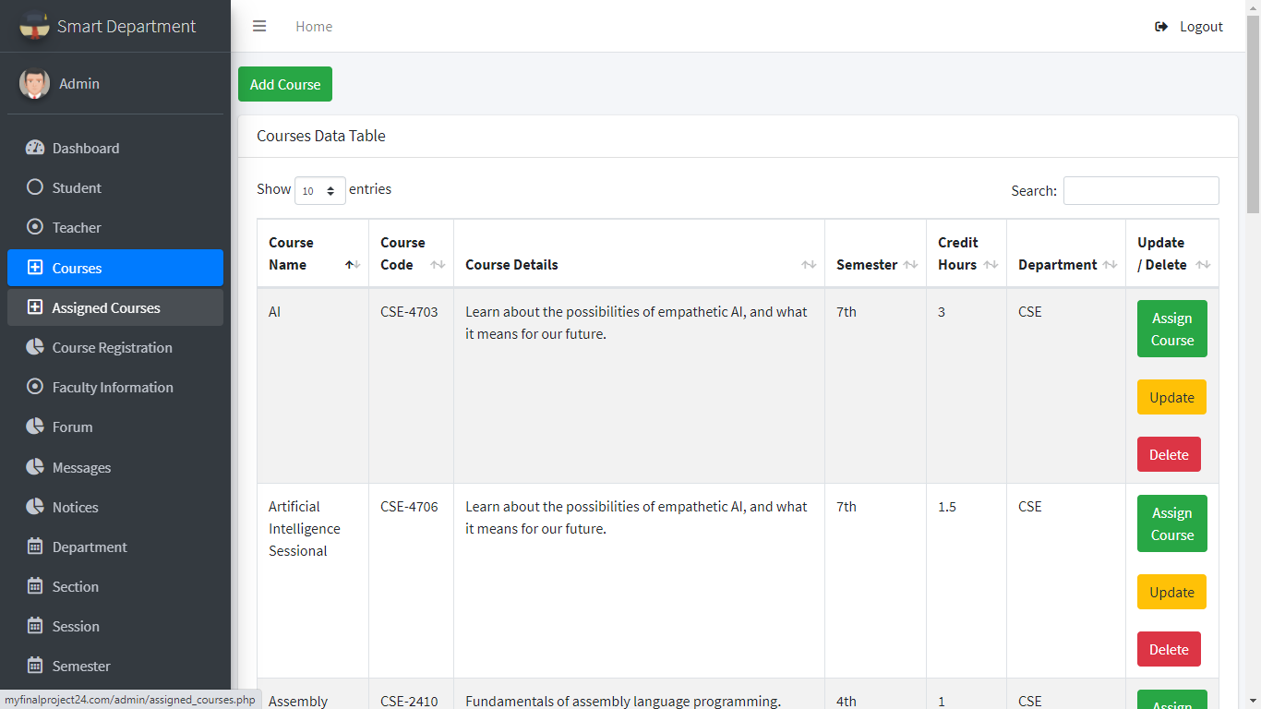

Fig 6.23: Course Management for Admin

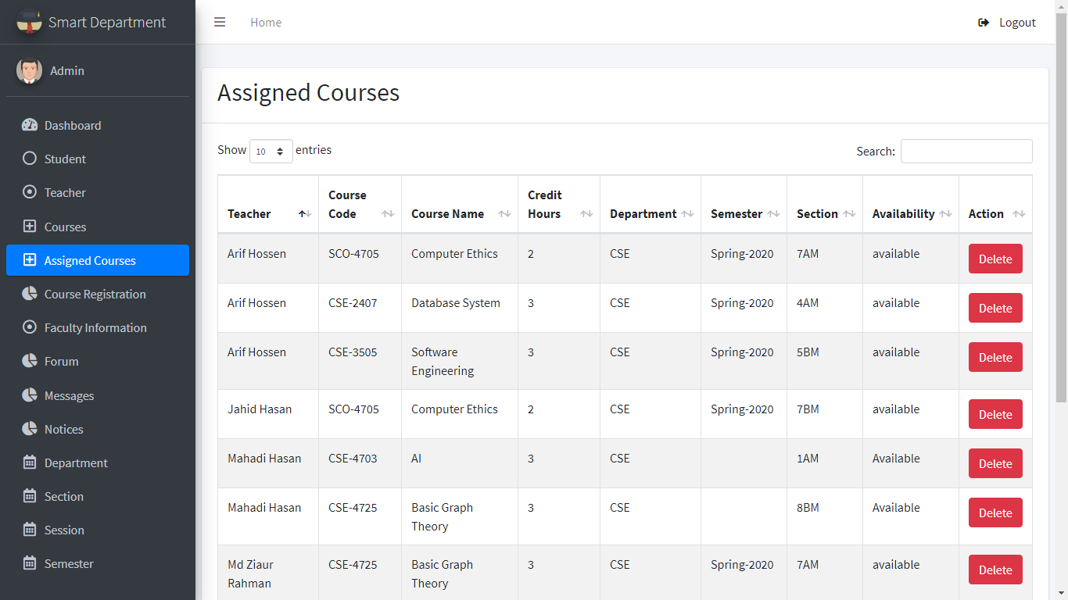In this course activity admin can add course. Here admin also can assign course to the teacher and can update and delete courses.

# 

# 

# 

Fig 6.24: Assigned Course Management for Admin

Here admin can see the assigned courses to the teachers. Admin also can delete the courses according to semester.

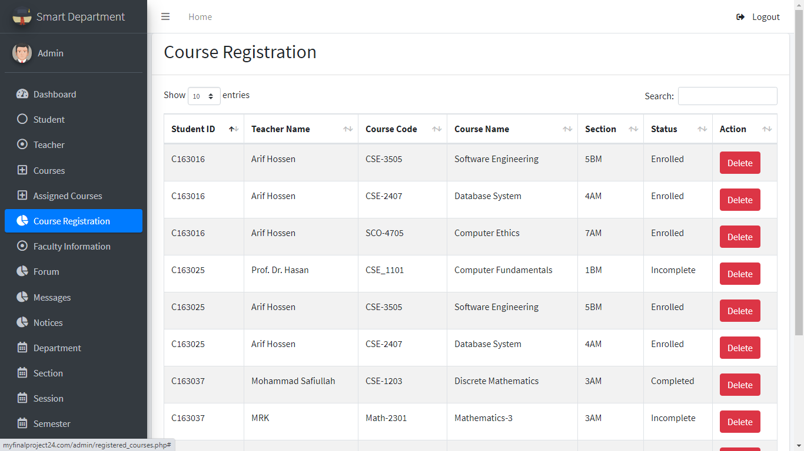

# 

Fig 6.25: Course Registration Management Activity for Admin

Here admin can see the registered courses by the students. Which student have taken which course under which teacher will be shown here. Admin also can see the status of the registered course.

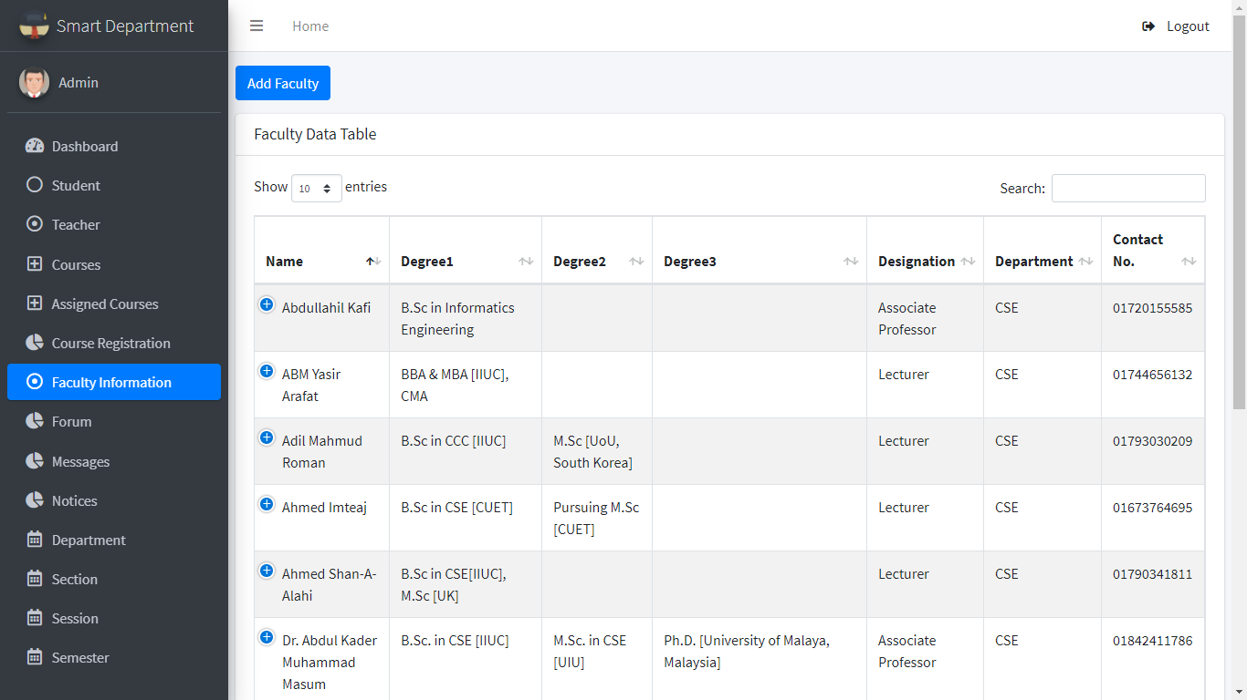

# 

Fig 6.26: Faculty Information Activity for Admin

Faculty Information activity shows the information of the faculty. Admin can manage faculty information of the department.

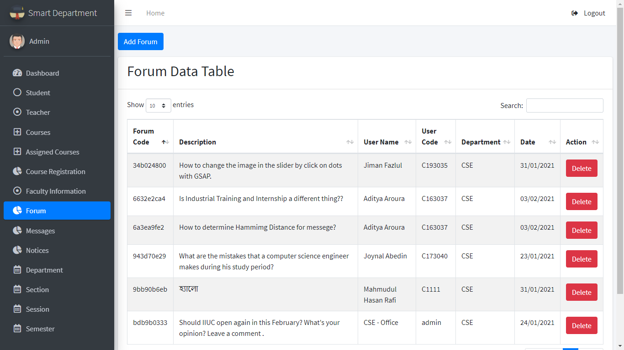

# 

Fig 6.27: Forum Management Activity for admin

In Forum activity admin can see the form posts and moderate the forum operation.

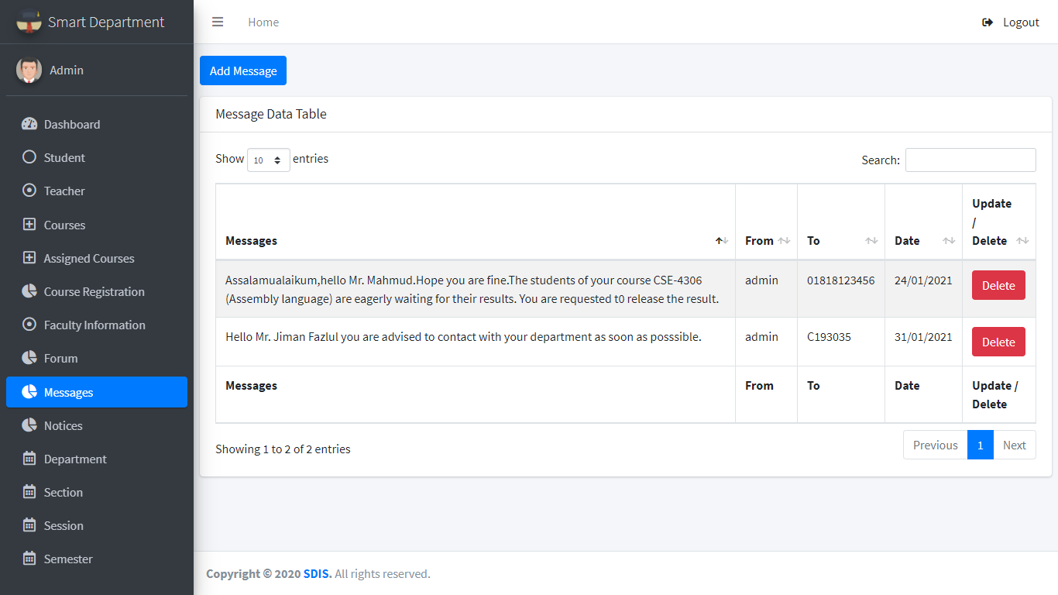

Fig 6.28: Admin Message Management Activity

Here admin can see the messages conversed with admin. Admin can send message to students and teacher both.

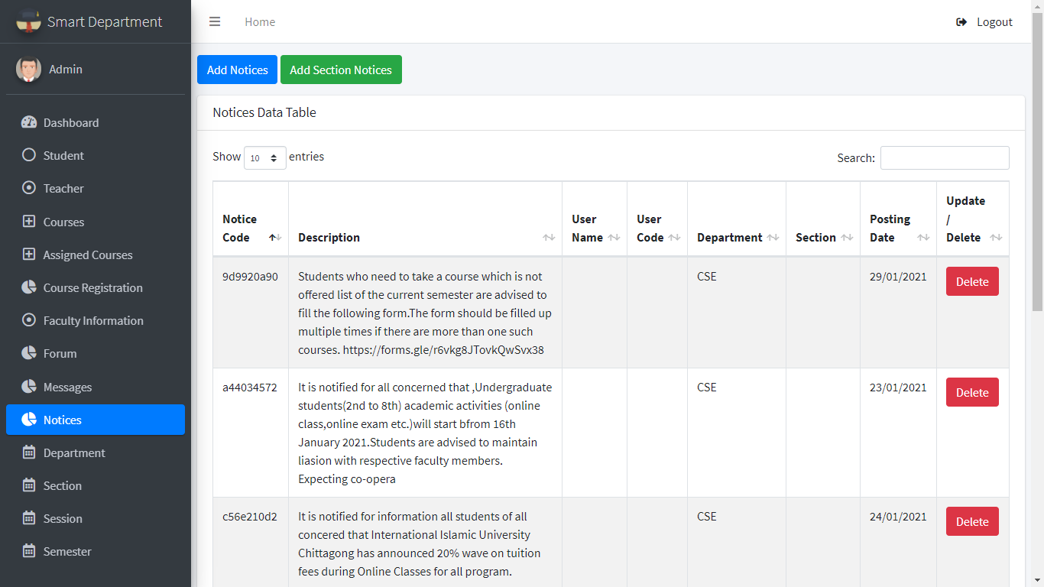

Fig 6.29: Admin Notice Management Activity

In notice activity admin can add official notices. Admin also can give sectional notices.

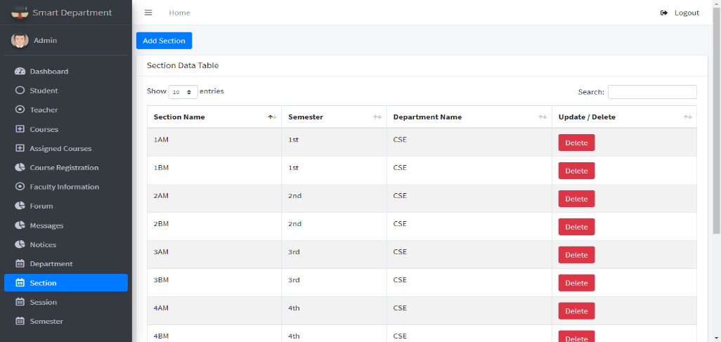

# 

Fig 6.31: Section Management Activity for Admin

In section management activity admin can add or delete section.

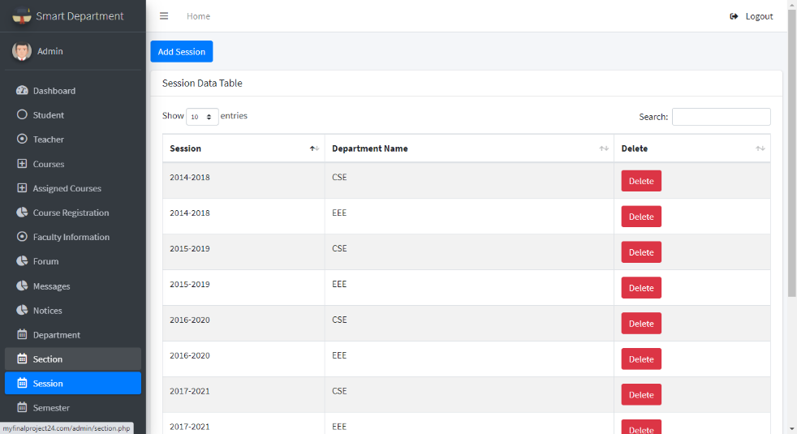

Fig 6.32: Session Management Activity for Admin

Form session activity admin can manage sessions of the department.

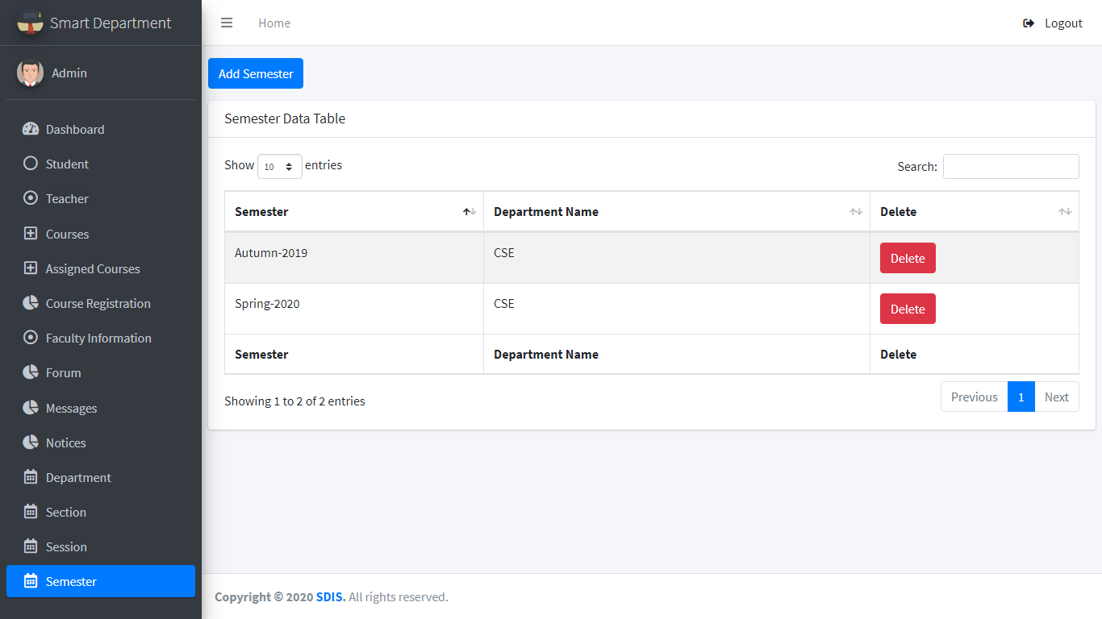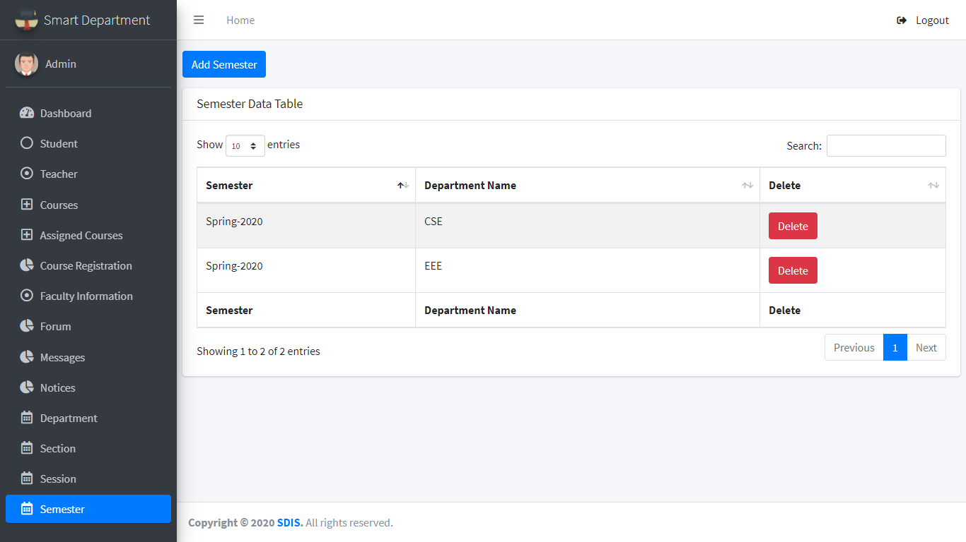

Fig 6.33: Semester Management Activity for Admin

In this semester activity admin can manage semester of the department.

6.3 TESTING

Testing is the process of verifying and validating the system. The objectives of testing are to ensure that the system programs is error free, guarantee the system end users can interact with the system well and ensure that the components of the system interface are working well.

6.3.1 Objectives of Testing

There have some different goals and objectives in software testing. The main objectives are as follows [16] -

1. Meets the requirements that guided its design and development.
2. Works as expected.
3. Can be implemented with the same characteristics.
4. To prevent defects.

6.3.2Testing Details

For our project we did two types of testing. As functional testing we did White Box Testing and as non-functional testing we did Usability Testing.

6.3.2.1 Functional Testing

* **White Box Testing**

In general, White Box Testing is performed early in the stage out. In this type testing all the lines, loops and logical expression and connections are tested by debugging the program [17] .We checked validation on every inputs of the project and debugged the system many times. There are few details:

* We have debugged all inputs which are mandatory as user inputs. We have tested another important field, file input. If file upload manager accepts all file type without specific one, then it can cause security issue to our database and server. We got error exception in debugger while checked with invalid or unknown file types.

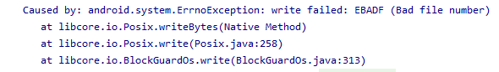

Fig 6.34: File type checking output

* 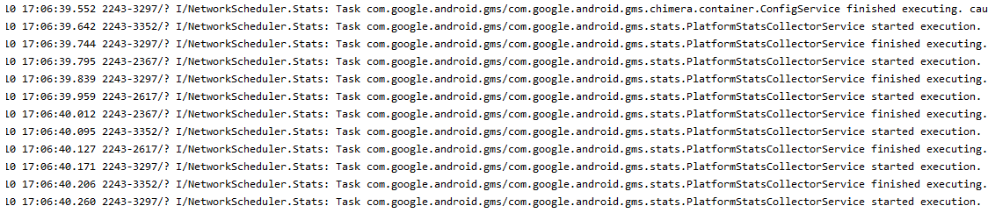App server connection request execution are tested with debugger network scheduler. We have completed this check without getting any error. At testing time it has started and finished execution with mentioned schedule request. No delay or error execution seen while testing.

Fig 6.35: connection request execution testing output

* 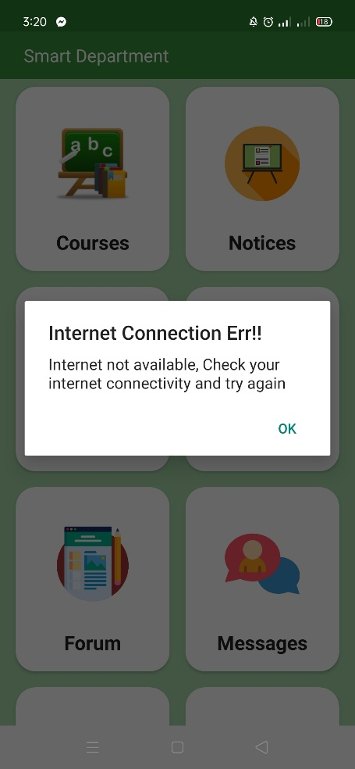App connectivity tested manually. In this test we have checked application connection manually. As we have used connection detector we see this application can detect no internet connectivity or connectivity with very lower bandwidth. It automatically stops running the application with validation to avoid operation failure.

Fig 6.36: Output of manual connection check of application

**6.3.2.2 Non-functional Testing**

* **Usability Testing**

Usability Testing is a non-functional testing approach. It means selecting some target user and let them use the application for a duration and get the feedback from the users. As our application is totally a new system with new concept. We did a usability testing to our system before launching it. We tested among 12 real users and the duration was 3 days of regular use. We got feedback from the users who have participated our usability test. In case of usability testing some question arises. Such as

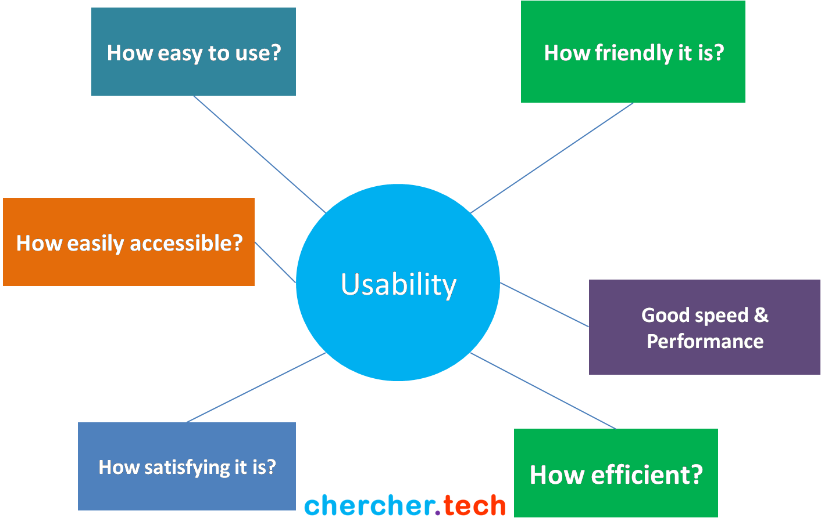

Fig 6.37: Usability Testing [20]

Some feedbacks from our usability testing are given below:

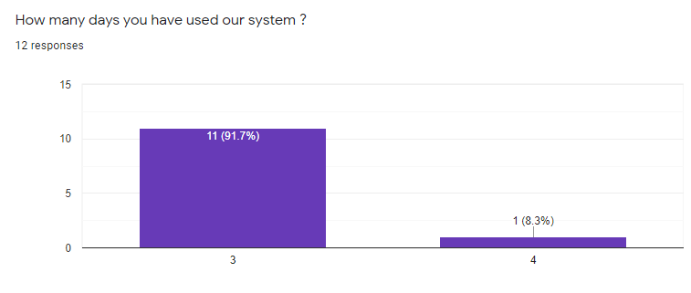

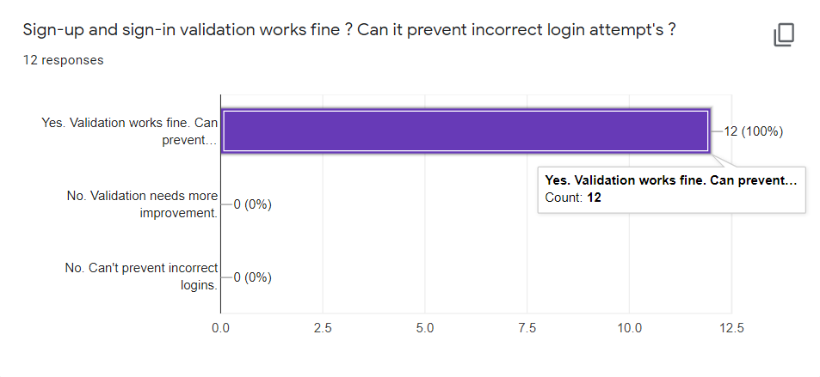(a)

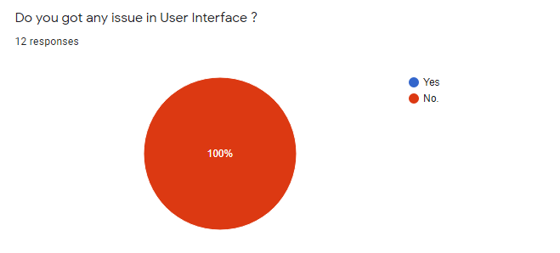(b)

(c)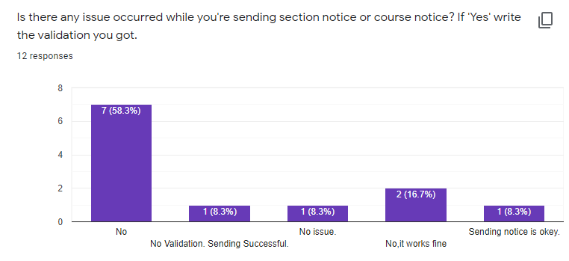

(d)

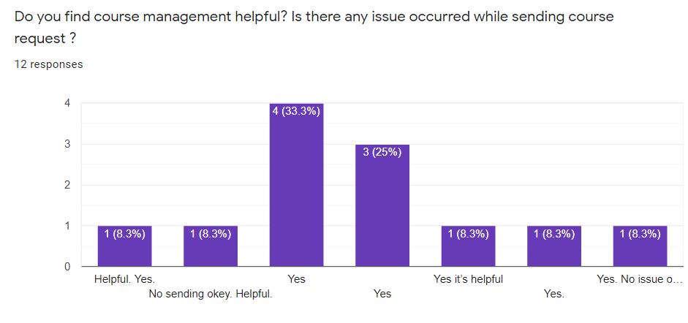

(e)

Fig 6.38: (a), (b), (c), (d) and (e) Usability testing user feedbacks

6.3.3 Advantage We Got From Testing

* Internal debates resolved by discussion from target audience demand, react and feedback.
* Potential issues and detectedproblems aresolved before final deployment.

chapter VII  
  
Conclusion & future plan

7.1 Conclusion

The project is developed with the aim to ensure the advantage of information system in academic processes of the department and to overcome the drawbacks of manual system. Our overall objective of the project **“**A Smart Course, Notice and Department Forum Management System” isto make it as an interactive information system for department which could be an easiest medium for the users to get in touch with academic information’s with maintaining proper securities for all important data. If the outcomes of the project can make the objective fulfilled it would be great achievement for the project.

7.2 Contribution of the project

The project “A Smart Course, Notice and Department Forum Management System” will be able to contribute in academic department by making the work environment of the department easier and informative. Also, it will help to build a strong communication point between the teachers and students. It will reduce waiting time in academic processes. It will make the course management easier and efficient and also will to make an interactive community within the department and ensure the advantage of it in academic processes of the department.

7.3 Future Plan

* We will try to make the application signed and deploy it to app store.
* We will try to include some new feature to the application in future to make the application up-to-date for end users.
* We will ensure the maintenance of application regularly.

**REFERENCES**

[1] Blackboard Inc., Washington, D.C., U.S. *Private Chat in Blackboard Collaborate with the Ultra Experience* (June 1, 2018). [Online Video]. Available: [https://www.youtube.com/watch? v=xvOuyj_vROw](https://www.youtube.com/watch?%20v=xvOuyj_vROw)

[2] Orell TechnoSystems. “Orell eDo.” *Orell eDo : World class e-learning software.*<https://www.orelledo.com/student-interface.php> (accessed Jan 18, 2021)

[3] “Moodle.”*What is Moodle? - Comprehensive Guide to Moodle LMS.*<https://ethinkeducation.com/what-is-moodle-guide> (accessed Jan 9, 2021)

[4] “Canvas LMS.” *To the power of the canvas learning management system.*<https://www.instructure.com/canvas> (accessed Feb 1, 2021)

[5] “AlphaLearn LMS”. *AlphaLearn Learning Management System (LMS).* <https://play.google.com/store/apps/details?id=com.horizzon.alphalearn&hl=en&gl=US> (accessed Feb 8, 2021)

[6] “Classe365”. *Classe365 Pricing, Features, Review and Alternatives.*<https://www.getapp.com/education-childcare-software/a/classe365/>(accessed Feb 8, 2021)

[7] “Requirements Engineering”. *Requirements Engineering - Requirements Validation Part – 4* . <https://medium.com/omarelgabrys-blog/requirements-engineering-requirements-validation-part-6-29778d7bde24>(accessed 09 Feb, 2021)

[8] Scott Ambler, “Agile Modeling” in *Agile Modeling : Effective Practices for eXtreme Programming and the Unified Process*, New York, 2002, pp. 08-16

[9] NataliaPeterheria. “Agile Modeling”. Why Agile SDLC Model Is The Best for Startup. <https://producttribe.com/project-management/agile-sdlc-guide> (accessed Jan 25, 2021)

[10] “Agile Software Model”. Agile Model for Software Development Lifecycle. <https://nextbigtechnology.com/agile-model-for-software-development-lifecycle> (accessed Jan 25, 2021)

[11] “Disadvantage of agile methodology.” *3 Disadvantages of agile methodology*.<https://www.lucidchart.com/blog/3-disadvantages-of-agile-methodology> (accessed Feb 3, 2021)

[12] “Agile Modeling.”*InformIT: The Trusted Technology Source for IT Pros and Developers*. <http://www.informit.com/articles/article.aspx?p=30428> (accessed Jan 25, 2021)

[13] “System Analysis”.*System Analysis and Design – Overview.*<https://www.tutorialspoint.com/system_analysis_and_design/system_analysis_and_design_overview.htm>(accessed Feb 4, 2021)

[14] “Software Process”. *A General Model of Software Design Process.* <https://www.slideshare.net/JenniferPolack/software-process-56762366>(accessed Jan 28, 2021)

[15] Scott W. Ambler. “Agile Modeling .”*An Introduction to Agile Modeling.*<http://www.agilemodeling.com/essays/introductionToAM.htm> (accessed Jan 25, 2021)

[16] “Software Testing Objective”. *Software testing objective and purposes*. <https://www.toolsqa.com/software-testing/istqb/software-testing-objectives/> (accessed Feb 8, 2021)

[17] “White Box Testing.” *What is White Box Testing? Techniques, Example and Type*. <https://www.guru99.com/white-box-testing.html>(accessed Jan 20, 2021)

[18] Software Design Center (2006), “How to Draw Data Flow Diagrams”, 2006,

Collected from “http://www.smartdraw.com/tutorials/software-dfd/dfd2.htm”,

[19] Software Design Center (2006), *“How to draw Entity Relationship Diagrams”*, 2006, Collected from “https://www.smartdraw.com/entity-relationship-diagram/”,

[20] “Software Usability Testing”. Software testing approaches <https://chercher.tech/images/testing/?MD> (accessed Jan 25, 2021)

**The End**